**Combined Unitary &**

**Same-as-Federal**

**Consolidated Returns**

***Understanding and Application***

October 2019

**Disclaimer**

*The information in this manual is for educational and informational purposes only and does not constitute legal advice. Information is presented as an overall review that is subject to law changes and may not apply to all states. For accurate information on issues related to unitary combined and elective consolidated filing, please reference KRS 141.201, KRS 141.202, 103 KAR 16:200, and 103 KAR 16:400.*

*Information in this manual is believed to be accurate as of the date of publication. In the event that any information in this manual is later determined to be in error, this manual cannot be used by taxpayers in supporting a specific position or issue before the Department of Revenue, as it does not have the statutory or regulatory authority.*

Contents

BACKGROUND 4

NEXUS CONSOLIDATED RETURN 4

COMBINED UNITARY RETURN 5

**What is a unitary business?** 5

***Supreme Court decisions on the unitary business concept*** 6

**Which entities are included in the combined report?** 7

**Apportionment** 11

**Combined Return Filing Rules** 13

**Net Operating Losses (NOLs)** 19

COMPREHENSIVE EXAMPLE 23

ELECTIVE CONSOLIDATED RETURN 47

**Elective Consolidated vs. Combined** 47

**Apportionment** 48

**Net Operating Losses (NOLs)** 49

**Consolidated Loss Limitation Rules** 50

**Elective Consolidated Filing Rules** 52

APPENDIX 54

# BACKGROUND

2018 House Bill (HB) 487, which became law on April 27, 2018, changed the filing requirements for corporations doing business in Kentucky and in other states. For tax years beginning on or after January 1, 2019, multi-state corporations doing business in Kentucky must file ***combined*** ***unitary*** returns, unless they elect to file ***same-as-federal consolidated*** returns. This is a change from the ***mandatory nexus consolidated*** returns required for tax years beginning on or after January 1, 2005 and ending on or before December 31, 2018. Separate entities operating in Kentucky will continue to file separate-entity returns.

This is not the first time that Kentucky has required corporations to report income under the unitary business concept. In the years before 1995, Kentucky also required combined unitary returns. In 1996, in the wake of the Kentucky Supreme Court decision in *GTE v. Revenue Cabinet*,Kentucky abolished combined unitary returns and required corporations to file separate-entity returns, unless they elected to file a same-as-federal consolidated return, for filing years beginning on or after January 1, 1996. This regime changed in 2005 when the Legislature passed a sweeping tax modernization plan, and Kentucky required mandatory nexus consolidated returns for multi-state corporations. With 2018 HB 487, the Legislature re-instituted combined unitary returns.

# NEXUS CONSOLIDATED RETURN

KRS 141.200 requires the filing of mandatory nexus consolidated returns through the end of December 2018. As the name implies, the entities in a nexus consolidated group must all have nexus in Kentucky, defined by KRS 141.010(7) as “doing business” in Kentucky. (“Doing business” was defined by KRS 141.010(25) for tax years 2005-2017). The “doing business” standard for establishing nexus generally means that an entity is either domiciled in Kentucky or has sales, property, or payroll in Kentucky, or otherwise derives income from sources in Kentucky (such as receiving income from a pass-through entity that is doing business in Kentucky). The corporations in a nexus group also must be connected through at least 80% stock ownership with a common owner that is also an includible corporation. Finally, each corporation included in the return must meet the “includible corporation” requirements in KRS 141.200(9)(e). KRS 141.200(9) thru (14) define which entities are included in a nexus consolidated return.

Membership in a nexus group can be verified by the ownership information provided on the affiliation schedules (Form 851 and 851-K) and by the sales, property, and payroll information provided on the Schedule A-N (or page 2 of the Schedule A) filed with the return. An entity that has nexus in Kentucky but does not meet the 80% ownership threshold is excluded from the nexus group and must either file separately or as part of a separate mandatory nexus consolidated group if it is part of a separate chain of corporations that meets the ownership, includible corporation, and nexus requirements.

# COMBINED UNITARY RETURN

KRS 141.202 requires that a taxpayer engaged in “a unitary business with one or more other corporations shall file a combined report” for tax years beginning on or after January 1, 2019. The combined report includes “all corporations that are members of the unitary business.” Unlike a mandatory nexus group, the corporations included in a unitary group do not all need to have nexus in Kentucky. KRS 141.202(2)(f) states that the entities included in a combined report should be “separate parts of a single corporation” or “a commonly controlled group of corporations.” 2019 HB 354 (passed March 2019) clarified that “control” means more than 50% voting-stock ownership by a common owner that is also part of the unitary business [KRS 141.202(2)(a)]. The applicable regulation for combined unitary filing is 103 KAR 16:400.

Taxpayers must address two fundamental questions regarding combined filing:

1) What is a unitary business?

2) Which entities are included in the combined report?

## **What is a unitary business?**

Kentucky law defines a unitary business as “a single economic enterprise that is made up either of separate parts of a single corporation or of a commonly controlled group of corporations that are *sufficiently interdependent, integrated, and interrelated* through their activities so as *to provide a synergy and mutual benefit* that produces a sharing or exchange of value among them and *a significant flow of value to the separate parts*” [KRS 141.202(2)(f)].

What that means, in a nutshell, is that one part of a business derives a benefit from at least one other part of that same business—irrespective of domicile, state of nexus, or particular activity. For example, suppose Company A makes money by selling widgets in Kentucky. Part of its widget-selling success, however, derives from the management expertise provided by Headquarters, the marketing expertise of the Corporate Brand Management division, and the transportation efficiencies provided by Widgets Logistics, Inc. Company A’s widget-selling business is therefore “unitary” with those other entities, which may have no apportionment factor presence in Kentucky.

Without limiting the scope of what constitutes a unitary business, the presence of the following circumstances likely indicate the existence of a unitary business when conducted by two or more commonly controlled companies:

* Companies engaged in the same line or similar lines of business.
* Companies engaged in different steps of a vertically structured business.
* Companies controlled by strong centralized management.
* Economies of scale that allow for mutual benefit to companies.
* One company exercises significant control over another company or companies.
* Companies engaged in intercompany business transactions, particularly relating to products, services, intellectual property, or financing that are significant to the businesses’ operations.

Because the unitary concept has been around for a while, the U.S. Supreme Court has had a chance to weigh in on it through several cases. The Court looks to three characteristics to determine if a business is unitary: Functional integration, centralized management, and economies of scale. Functional integration means that the functions of the business are interdependent; in other words, a single entity within the business cannot stand alone and succeed. Centralized management looks to who has an operational role in business activities. 103 KAR 16:400 §4(6)(b) states that “centralization of management may exist even if day-to-day management responsibility … has been decentralized, if the management has an ongoing operational role with respect to the business activities.” And economies of scale means that there are operating efficiencies gained by the common ownership of different companies.

### ***Supreme Court decisions on the unitary business concept***

The early 1980s saw a flurry of cases appealed to the Supreme Court that refined the unitary business concept. In *Mobil Oil Corp vs Commissioner of Taxes* (1980), the Court determined that Vermont could collect tax on its apportioned share of Mobil Corp’s dividend income paid to the parent by the company’s foreign subsidiaries. Mobil was such a highly integrated operation, from exploration and development to retail sales at the gas pump, that the Court decided that it was one unitary business. Even though its activities in Vermont consisted of just gas stations and gasoline wholesalers, Vermont was able to reach out and collect its apportioned share of Mobil’s income that came from its offshore subsidiaries (445 US 425).

In 1982, Woolworth Company, which owned and operated chain stores in the United States and Europe, appealed an assessment by the New Mexico Taxation Department that included the dividend income paid to the parent by its European subsidiaries as part of the New Mexico apportionable income base. The Court found that even though the European subsidiaries were 100% owned by the parent and that the parent appointed the boards of directors of the foreign subsidiaries, the stores were sufficiently independent regarding everyday business decisions like site selection, merchandise selection, advertising, and accounting that it did not consider the business unitary (458 US 354).

Also in 1982, the Court ruled on *Asarco Inc. vs Idaho State Tax Commission*. Asarco was a vertically integrated mining, smelting, and minerals marketing corporation that had a silver-mining operation in Idaho. It also owned a 51.5% stake in a copper-smelting subsidiary in Peru, which sold about 35% of its output to Asarco and paid dividends to the parent company. Idaho wanted to tax an apportioned amount of those foreign dividends. The Court ruled in favor of Asarco, saying that the smelting business was not unitary with the silver-mining activity in Idaho. It based its ruling partly on the fact that the ownership documents limited Asarco’s control over the Peruvian subsidiary (458 US 307).

In 1983, the Court ruled that Container Corporation of America’s foreign subsidiaries were part of the company’s unitary business and that, therefore, California could tax an apportioned part of the income derived from those foreign operations. The Court based its decision on the fact that the parent held or guaranteed 50% of the subs’ long-term debt and that the parent provided managerial and technical assistance, even though the subsidiaries operated relatively autonomously in their day-to-day operations and bought only about 1% of their materials from the parent (463 US 159).

The varied outcomes of these cases shows that the determination of whether or not a business is unitary depends heavily on the particular fact pattern for each specific taxpayer. Desk audits performed by the DOR will generally not have access to the in-depth corporate information required to make a determination as to whether or not a unitary business exists; such questions may, however, be addressed during a field audit.

## **Which entities are included in the combined report?**

Not all entities that are part of the unitary business are included in the combined report. A combined group includes only C Corporations, at least one of which is subject to the corporate income tax in Kentucky per KRS 141.040. In Kentucky, the definition of a combined group also generally adheres to a “water’s-edge” concept, meaning that entities in the group should be incorporated in the United States, the District of Columbia, or any territory or overseas possession of the United States. However, a domestic company that earns 80% or more of its income from foreign sources is excluded from the group.

The water’s-edge concept is also modified by the requirement that the group must include those entities that are part of the unitary business that do business in a tax haven, defined by KRS 141.202(2)(d). However, 2019 HB 354 clarified that any country with a comprehensive income tax treaty with the United States is not considered a tax haven.

Finally, any entity that earns more than 20% of its income from payments from other members of the unitary group for “intangible property or service related activities that are deductible against the apportionable income of other members of the combined group” must be included in the combined group to the extent of that income [KRS 141.202(8)(b)]. This provision is designed to prevent income shifting between related entities where an entity is charged for the use of intangible assets or management services provided by another entity in the group. 2019 HB 458 clarified, however, that if an offshore company met the 20% threshold, the income would not have to be included in group income if the offshore company’s income is excluded from U.S. taxation by a comprehensive income tax treaty.

It is possible that a single member of a combined group may be individually engaged in more than one unitary business. In that case, a single entity could be a member of two or more combined groups. It is also possible that a commonly owned group of companies may be engaged in more than one unitary business.

Business conducted by a pass-through entity that is directly or indirectly held by a corporation is considered the business of the corporation to the extent of the corporation's distributive share of the pass-through entity income, inclusive of guaranteed payments. Any business conducted directly or indirectly by one corporation is unitary with that portion of a business conducted by another corporation through its direct or indirect interest in a pass-through entity if there is a mutual benefit and a significant sharing or exchange of value between the two parts of the business and the two corporations are members of the same group of business entities under common ownership.

The graphic below illustrates which corporations should be included in the combined group according to the Kentucky statutes.

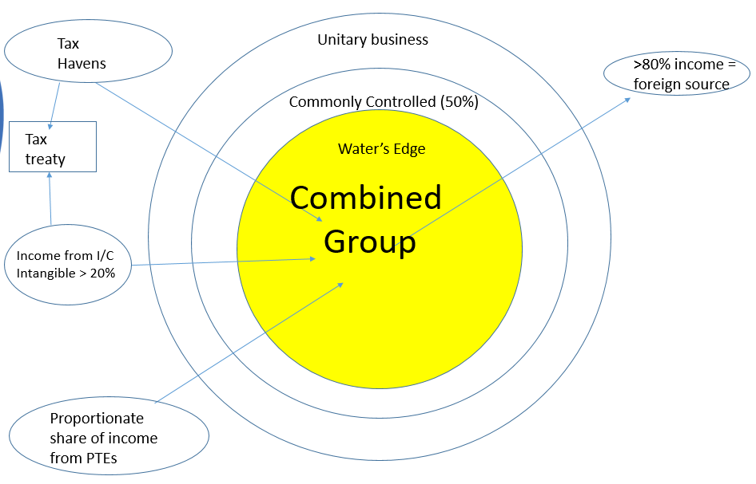

The following examples illustrate different corporate structures and which entities should be included in a combined report. KRS 141.202(3)(b) gives the Department the authority to bring in corporations that the Department determines to be a part of the unitary business that the taxpayer has not included.

Example 1

* All companies are C-Corps.
* E has no sales, property, or payroll in Kentucky. All other corporations have Kentucky nexus.
* Company is a vertically integrated plastics manufacturer.
* Unrelated Corp sells 80% of its output to A, which is domiciled in Kentucky.

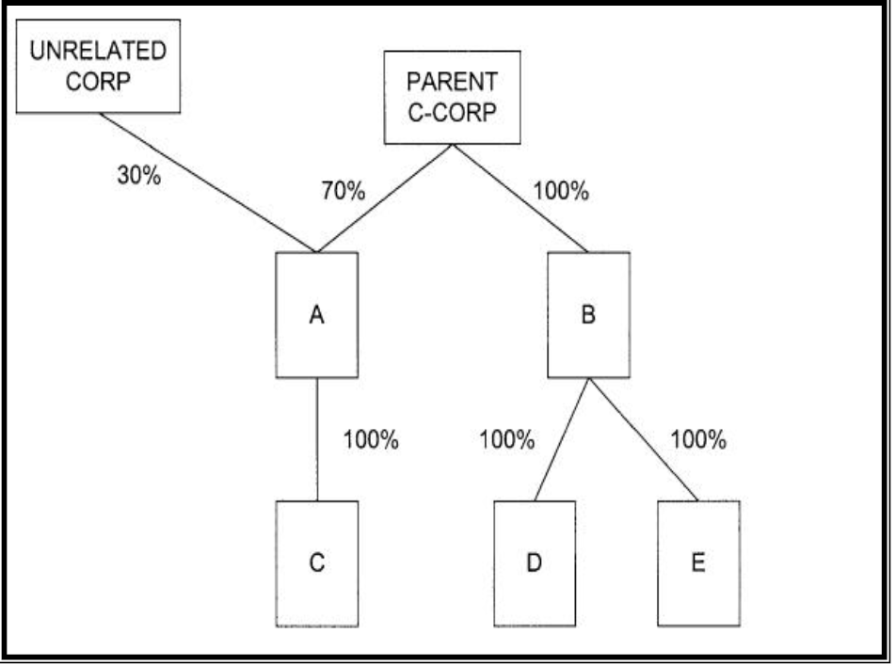

The combined group consists of (Parent + A + B + C + D + E).

Unrelated Corp is not included, but would have a filing requirement in Kentucky because of its sales into the state.

Example 2

* All companies are C-Corps.
* E does not have sales, property, or payroll in KY.
* Parent is a holding company without Kentucky nexus.
* Sub A and affiliated companies manufacture and sell auto parts.
* Sub B and affiliated companies recycle plastic and metal and sell recycled products.
* Percentages shown below reflect voting stock ownership.



49%

51%

Membership in the combined group depends on the fact pattern. Do the manufacturing division and the recycling division operate autonomously and independently of each other? If so, you may have two unitary businesses; one consisting of (Parent + A + C + D) and the other consisting of (Parent + Sub B + E + F). However, if the divisions are functionally integrated (perhaps the parent provides technical and managerial assistance or Sub B buys most of its recycling materials from Sub A), then all the entities would be included in a single unitary business.

Example 3

* All companies are C-Corps.
* Company provides software (both physical media and cloud-based) and technical service to clients.
* E is domiciled in Kentucky but makes 90% of its sales to overseas customers.



The combined report would include (Parent + A + B + C + D).

All the entities participate in the unitary business, but not all are included in the combined report. Company A is included in the combined report despite not having Kentucky nexus. Remember, Kentucky nexus does not determine membership in a combined group. Company E is not included in the combined report under the 80/20 rule on foreign sales. Company E would still have a filing obligation in Kentucky.

Example 4

* Company provides dialysis services through local clinics.
* LLC 3 does not have sales, property, or payroll in Kentucky.



The unitary group consists of (C-Corp + LLC 1). LLC 1’s distributive share of the income passed through from LLC 2 and LLC 3 is included in LLC 1’s income. As with mandatory nexus filing (and elective consolidated filing), all group members must be corporations (or pass-through entities electing to be taxed as corporations).

## **Apportionment**

2018 HB 487 moved Kentucky from three-factor (sales, property, and payroll) apportionment to single-weighted receipts-factor apportionment for tax years beginning on or after January 1, 2018, for most businesses. For a unitary business, the basic apportionment calculation per KRS 141.120 (9) is:

Entity Gross Receipts (related to the unitary business) in Kentucky

Group Gross Receipts (related to the unitary business) Everywhere

KRS 141.121(3) maintains the previous three-factor apportionment formula for companies designated as “providers” by KRS 136.602. KRS 141.121 also continues to provide alternative apportionment formulas for certain types of companies, as well as allowing companies to propose an alternative apportionment method if they feel the single-receipts-factor formula does not represent the true extent of their business in the state [KRS 141.120(12)].

Since each taxpayer member of a combined group calculates its own apportionment factor, group members that are providers or that use alternative apportionment should continue to use the calculations appropriate to their businesses. In addition, KRS 141.206(9)(a)(2) provides that a corporation that owns an interest in a limited liability pass-through entity or a general partnership include its proportionate share of sales of the limited liability pass-through entity or general partnership in computing its own apportionment factor.

* **Receipts Factor.** KRS 141.120(1)(e) provides that receipts means all gross receipts of the corporation, excluding nonapportionable income. Nonapportionable income (formerly called “non-business” income) typically includes rents, royalties from intangibles, capital gains, interest income, etc. KRS 141.120(4)-(8) provides the statutory authority for allocating different types of nonapportionable income to Kentucky.
* **Market-based sourcing**. 2018 HB 487 introduced market-based sourcing to Kentucky as of January 1, 2018. These sourcing rules determine when receipts should be included in the numerator (“Kentucky receipts”) of the apportionment factor calculation. 103 KAR 16:270 provides numerous examples of when receipts for tangible goods, services, and intangibles should be sourced to Kentucky.
* **Calculating Net Income for a Combined Group.** KRS 141.202(4) states that “the use of a combined report does not disregard the separate identities of the taxpayer members of the combined group.” Therefore, with a combined return, each entity calculates its own apportionment factor. The separate apportionment factor is then multiplied by the combined group’s apportionable income from the unitary business to derive each member’s net income for Kentucky. For example, consider a simple two-entity unitary group: Company A has nexus in Kentucky; Company B does not have nexus.

|  |  |  |  |
| --- | --- | --- | --- |
|  | KY receipts | Receipts Everywhere | KY net income |
| Company A | $100,000 | $600,000 | $50,000 |
| Company B | $ 0 | $400,000 | $30,000 |
| Total | $100,000 | $1,000,000 | $80,000 |

Company A apportionment factor: $ 100,000 = 10%

$1,000,000

Company B apportionment factor: $ 0 = 0%

$ 1,000,000

Combined income (after state adjustments): $50,000 + $30,000 = $80,000

Company A Net Income: 10% x $80,000 = $8,000

Company B Net Income: 0% x $80,000 = $0

Group Tax: $8,000 x 5% = $400

## **Combined Return Filing Rules**

* The Department of Revenue has issued a new regulation 103 KAR16:400 to provide guidance to taxpayers filing a combined unitary return.
* **Taxpayer Members and Non-Taxpayer Members.** The members of a combined group are divided between “taxpayer members” and “non-taxpayer members.” Taxpayer members are those that are doing business in Kentucky and thus subject to taxation under KRS 141.040. Each taxpayer member of the combined group needs a Kentucky Corporate account number. Non-taxpayer members are entities that are included in the unitary business but not subject to tax in Kentucky.
* **Designated filer.** KRS 141.202(9) states that a combined group “shall annually designate one (1) taxpayer member of the combined group to file a single return.” This designated filer consents to act as surety for the tax liability of all other taxpayer members of the combined group and as agent for any matters that might arise related to the return. There is no separate designation form necessary; rather, the named filer on the face of the combined return in the first year that a combined group files a combined return for Kentucky is the designated filer.
* **Separate responsibility.** Notwithstanding the designation of a filing member for the group, each taxpayer member of the group is separately responsible for tax based on its taxable income or loss apportioned and allocated to Kentucky.
* **Separate Credits.** Tax credits cannot be shared among members of the combined group or used to offset the income of the combined group. They can only be used to offset the income of the entity that generated them. Likewise, credit carryforwards stay with the entity that generated them.
* **Overpayments.** If a member of a combined group has a prior-year credit for an overpayment of taxes from a taxable year before it was a combined group member, the member may, through its designated filer, authorize the department to apply some or all of the credit against the total tax liability reported on the combined return. The designated filer will need to notify the department in writing of the amount to be applied. Alternatively, the member may file a claim for refund of the overpayment on Form 40A100, in which case the overpayment will be refunded to that member.
* **Overpayments when a member leaves the group.** If a corporation leaves a combined group that has an overpayment of taxes carried over from a prior combined return year, the designated filer may allocate a portion of that overpayment to the former member. The designated filer shall notify the department of the amount to be allocated to the former member via a letter signed by an authorized representative.
* **Members have different taxable years.** If a member of the combined group has a different taxable year than the combined group, the designated filer must choose one of the following methods to determine how to include the member’s income in the combined report:
  + It can prepare a separate income statement based on the books of the non-conforming member that shows the member’s income for the months included in the combined group year; or
  + It can include the total income reported by the member on its regular income statement for the taxable year that ends during the combined group’s taxable year.

Once the designated filer chooses a method, it must apply the same method to each member with a different taxable year, and it must use this method consistently from year to year, unless it seeks prior approval from the Department to change.

* **Apportionable income.** Each taxpayer member calculates its share of the group’s unitary business income apportionable to Kentucky. The group’s income equals the sum of the individual net incomes of all members of the combined group [KRS 141.202(4)]. The individual members’ net incomes are determined by removing all but apportionable income from a member’s total income. Each member of the combined group calculates its net income as if it were filing a separate Kentucky corporate income tax return, subject to the following modifications in KRS 141.202(8):
  + **Intercompany transactions.** Gains and losses on intercompany transactions are deferred per 26 C.F.R. 1.1502-13. The deferred income is restored to the seller’s income when the object of the transaction is resold to an entity outside the combined group or is resold to or converted by a combined group member for use outside the unitary business. The seller also recognizes the income if the buyer and the seller are no longer part of the same combined group [KRS 141.202(8)(e)].
  + **Charitable contributions.** Charitable contributions are first deducted against the apportionable income of the combined group up to the limitations of IRC Sec. 170. If an amount is left over after the federal limitation is applied, it is treated as a nonapportionable deduction by the member that made the contribution, deductible against the nonapportionable income of that member. If there is still an amount remaining, it is carried over to the subsequent year, and the expense is treated as if it was incurred in that year [KRS 141.202(8)(f)]. See the example below.

**Example: Charitable Contribution Limitation**

The members of a combined group had the following amounts of apportionable income and nonapportionable income and made the following charitable contributions during the tax year:

|  |  |  |  |  |
| --- | --- | --- | --- | --- |
|  | **Apportionable income (including contributions)** | **Charitable contributions** | **Apportionable income (before contributions)** | **Nonapportionable income allocated to Kentucky** |
| Member A | $2,000 | $4,000 | $6,000 | $2,500 |
| Member B | $3,000 | $1,000 | $4,000 | $0 |
| Member C | $3,000 | $3,000 | $6,000 | $0 |
| Member D | $2,000 | $0 | $2,000 | $0 |
| **Total** | **$10,000** | **$8,000** | **$18,000** |  |

The combined group’s charitable contribution limit per IRC Section 170 is $1,800 (10% of $18,000, the total income before the charitable contribution deduction). Each member can then deduct its pro rata share of the amount remaining after the group’s $1,800 total deduction against its own nonapportionable income, subject to the Sec 170 limitations on that income. Member A would thus be the only member of the group who could utilize any portion of its unused charitable contribution on the current year’s return.

The following shows the amount of the charitable deduction each member can deduct against its nonapportionable income on the return for the current year and the amount that it carries forward to the next income year:

|  |  |  |  |  |
| --- | --- | --- | --- | --- |
|  | Percentage of total contributions | Pro-rata share of remaining contributions* | Allowable contribution deduction** | Carryforward |
| Member A | 50% | $3,100 | $250 | $2,850 |
| Member B | 12.5% | $ 775 | $ 0 | $ 775 |
| Member C | 37.5% | $2,325 | $ 0 | $2,325 |
| Member D | 0% | $ 0 | $ 0 | $ 0 |
| Total | 100% | $6,200 | $250 | $5950 |

*Remaining contribution amount = $6,200 [$8,000 total contributions - $1,800 group limitation].

**Allowable contribution deduction limited to 10% of nonapportionable income allocated to Kentucky

* + **Capital gains and losses and involuntary conversions.** Gains and losses from the sale or exchange of capital assets, Internal Revenue Code Section 1231 property, and property subject to an involuntary conversion are removed from the separate total income of the member of the group that incurred the gain or loss. Then the net gains and losses from each class of property are combined for the group (without netting between classes) and separately apportioned to each member. The net apportioned gains or losses from each classes are then netted against each member’s nonapportionable gains and losses from each classes that are allocated to Kentucky. If there is Kentucky-source income or loss remaining after this process, it can be used to offset that member’s other Kentucky-source income or loss [KRS 141.202(8)(g)]. See the example below.

**Example: Capital Gains and Losses**

The members of a combined group have a combined apportionable income of $1,000,000 before considering members’ gains and losses from the sale or exchange of capital assets, Section 1231 property, and property subject to an involuntary conversion. Apportionment factors for each member of the group are Corp X: 4%, Corp Y: 6%, and Corp Z: 3%.

**Step 1**: Separate the net gains and losses into their separate classes: short-term capital, long-term capital, IRC Sec. 1231, and involuntary conversions. Divide the amounts in each class by whether they are apportionable or allocable to Kentucky.

|  |  |  |  |  |
| --- | --- | --- | --- | --- |
|  |  | Corp X | Corp Y | Corp Z |
| **Net short-term capital gain/(loss)** | Apportionable | (75,000) |  |  |
| Allocable to KY | ** | 10,000 |  |
| **Net long-term capital gain/(loss)** | Apportionable |  | (50,000) | 15,000 |
| Allocable to KY |  |  | (5,000) |
| **Net Section 1231 gain/(loss)** | Apportionable | 100,000 | (25,000) | 125,000 |
| Allocable to KY |  |  |  |
| **Net gain/(loss from involuntary conversion** | Apportionable |  |  |  |
| Allocable to KY |  | 5,000 |  |

** Corp X has a capital gain of $25,000 allocable to another state.

**Step 2**: Combine all members' apportionable net gain and loss in each class, without netting between the classes.

|  |  |  |  |
| --- | --- | --- | --- |
| Aggregate apportionable short-term capital gain/(loss) | Aggregate apportionable long-term capital gain/(loss) | Aggregate apportionable Section 1231 gain/(loss) | Aggregate apportionable gain/(loss) from involuntary conversion |
| ($75,000) | ($35,000)* | $200,000** | $0 |

*($50,000) + $15,000

**$100,000 + ($25,000) + $125,000

**Step 3**: Apportion the gain and loss in each class according to the apportionment factor of each entity in the combined group.

|  |  |  |  |
| --- | --- | --- | --- |
|  | Corp X | Corp Y | Corp Z |
| Apportionment factor | .04 | .06 | .03 |
| Aggregate apportionable ST gain/(loss) | (75,000) | (75,000) | (75,000) |
| **Apportioned share of ST gain/(loss)** | **($3,000)** | **($4,500)** | **($2,250)** |
| Aggregate apportionable LT gain/(loss) | (35,000) | (35,000) | (35,000) |
| **Apportioned share of LT gain/(loss)** | **($1,400)** | **($2,100)** | **($1,050)** |
| Aggregate apportionable Sec. 1231 gain/(loss) | 200,000 | 200,000 | 200,000 |
| **Apportioned share of Sec. 1231 gain/(loss)** | **$8,000** | **$12,000** | **$6,000** |

**Step 4**: Add each member’s apportioned amount from each class to the amount from each class allocable to Kentucky for that member.

|  |  |  |  |
| --- | --- | --- | --- |
|  | Corp X | Corp Y | Corp Z |
| Apportioned share of ST capital gain/(loss) | (3,000) | (4,500) | (2,250) |
| ST capital gain/(loss) allocated to KY | 0 | 10,000 | 0 |
| **Total ST capital gain/(loss)** | **($3,000)** | **$5,500** | **($2,250)** |
| Apportioned share of LT capital gain/(loss) | (1,400) | ( 2,100) | (1,050) |
| LT capital gain/(loss) allocated to KY | 0 | 0 | (5,000) |
| **Total LT capital gain/(loss)** | **($1,400)** | **($2,100)** | **($6,050)** |
| Apportioned share of Sec 1231 gain/(loss) | 8,000 | 12,000 | 6,000 |
| Sec. 1231 gain/(loss) allocated to KY | 0 | 0 | 0 |
| **Total Sec. 1231 gain/(loss)** | **$ 8,000** | **$12,000** | **$ 6,000** |
| Apportioned share of gain/(loss) from involuntary conversions | 0 | 0 | 0 |
| Gain/(loss) from involuntary conversions allocated to KY | 0 | 5,000 | 0 |
| **Total from involuntary conversions** | **$0** | **$ 5,000** | **$0** |

**Step 5**: Net the amounts computed in Step 4 according to the rules of IRC Secs, 1231, 1222, and 1211 to compute each member’s net gain or loss. These rules specify that:

1) net capital losses can only be used to offset capital gains;

2) net short-term capital gains/losses are netted against net long-term capital gains/losses;

3) capital loss carryovers are classified as short-term capital losses;

4) net Section 1231 gains are treated as long-term capital gains; and

5) net Section 1231 losses are treated as ordinary losses.

|  |  |  |  |  |
| --- | --- | --- | --- | --- |
|  | Net Capital Gains and Losses | Total Sec. 1231 Gains and Losses | Total G/L from Involuntary Conversions | Net Gains and Losses |
| Corp X | ($4,400) | $ 8,000 | $0 | $ 3,600* |
| Corp Y | $3,400** | $12,000 | $5,000 | $20,400 |
| Corp Z | ($8,300) | $ 6,000 | $0 | ($ 2,300)*** |

*The net Sec 1231 gain is treated as a long-term capital gain, which offsets Corp X’s net capital loss position.

**Corp Y had a $5,500 short-term capital gain and a $2,100 long-term capital loss, resulting in a $3,400 net capital gain.

***Corp Z’s $8,300 net capital loss is offset up to its $6,000 of Sec. 1231 gain, which is treated as a long-term capital gain. The remaining $2,300 loss is a capital loss and cannot be used to offset ordinary income. It can be carried forward as a short-term capital loss to offset capital gains in future years [KRS 141.202(8)(g)(4)].

**Step 6**: Add the amount in Step 5 to each member’s apportioned share of the group’s net income

|  |  |  |  |  |  |
| --- | --- | --- | --- | --- | --- |
|  | Apportionment Factor | Combined Group Income (after removing G/L) | Apportioned Group Income | Total Net Gain/Loss | KY Taxable Income |
| Corp X | .04 | $1,000,000 | $40,000 | $3,600 | $43,600 |
| Corp Y | .06 | $1,000,000 | $60,000 | $20,400 | $80,400 |
| Corp Z | .03 | $1,000,000 | $30,000 | ($2,300)* | $30,000 |

*Corp Z’s ($2,300) capital loss cannot offset ordinary apportionable income. It can be carried forward as a short-term capital loss.

* + **Expenses related to nontaxable or non-apportionable income.** Deductions for expenses incurred by one member of the group that are attributable to nonapportionable or tax-exempt income of another member of the group are allocated to the other member of the group [KRS 141.202(8)(h)].
  + **Net Operating Losses (NOLs).** NOLs can be shared among members of the combined group subject to certain limitations. More detail on NOLs is provided in the separate section below.
* **Total income.** Each taxpayer member calculates its total tax due based on its separate total income after intercompany eliminations. Total income includes the following:
  + its share of the apportionable income of each of the combined groups of which it is a member;
  + its income apportionable to Kentucky from a distinct business activity carried on within and without Kentucky wholly by the taxpayer member;
  + its income from a business activity carried on only within Kentucky wholly by the taxpayer member;
  + its income sourced to Kentucky from the sale or exchange of capital assets and involuntary conversions;
  + its nonapportionable income allocated to Kentucky;
  + its income or loss allocated or apportioned to Kentucky from an earlier year that is required to be taken into account as Kentucky-source income during the current tax year; and
  + any net operating loss carryover.
* **LLET liability**. Each member of a combined group that is subject to the LLET under KRS 141.0401 will calculate its own LLET liability on a separate-entity basis. Once figured, these liabilities should be summed and payments (including estimated and extension payments) for all entities made by the designated filer. Members of the unitary business that may be exempt from income tax under Public Law 86-272 may be liable for LLET on receipts sourced to Kentucky.

## **Net Operating Losses (NOLs)**

With a combined report, Kentucky net operating losses are calculated on a post-apportionment basis, using the separate apportionment factor of each entity in the group. As a result, taxpayers will have to track each entity’s NOLs to know how much each entity has generated and can utilize. In addition, as Kentucky transitions from the mandatory nexus consolidated reporting regime to the combined unitary/same-as-federal consolidated regime, taxpayers will have to convert mandatory nexus pre-apportionment NOL carryforwards to post-apportionment NOL carryforwards. Finally, Kentucky’s updated IRC conformity date of December 31, 2018, means that the NOL carryforward provisions of IRC Section 172 also apply.

* **Each taxpayer member within the combined group calculates its NOL on a separate-entity basis.** If the net apportionable income of the combined group is a loss, each taxpayer member calculates its apportioned share of that group net operating loss. If the loss remains after adding the entity’s income separately allocated to Kentucky, it can be carried forward to future years.
* **Sharing of NOLs.** Net operating losses of a taxpayer member of the combined group can be shared with other taxpayer members of the combined group, with certain limitations. If the NOL was generated in a tax year in which a combined return was required and both the taxpayer member that generated the loss and the taxpayer member that utilizes the loss were in the combined group during that tax year, then the NOL can be shared, subject only to the 80% limitation imposed by IRC Sec. 172 for losses generated in tax years beginning on or after January 1, 2018 (see below).

When a taxpayer member of a combined group has an NOL carryforward from a tax year prior to the first year in which a combined return was required, it can still share the NOL with another taxpayer member of the group. However, the NOL deduction cannot exceed 50% of the “borrowing” taxpayer member’s Kentucky taxable income. The taxpayer member that originally generated the loss is not subject to this 50% limitation. The same 50% limitation applies to losses brought into the combined group by a taxpayer member from a year in which that member was not a taxpayer member of the combined group. However, per KRS 141.202(5)(c), “no prior year net operating loss carryforward shall be available to entities that were not doing business in this state in the year in which the loss was incurred.”

* **IRC Section 172**. Kentucky’s Internal Revenue Code conformity date is December 31, 2018. By updating its conformity date, Kentucky incorporated many of the provisions of the 2017 federal Tax Cuts and Jobs Act (TCJA) into Kentucky law. The TCJA amended IRC Section 172 regarding carryforwards of NOLs. Specifically, it limited the deduction for losses incurred in tax years beginning on or after January 1, 2018, to 80% of taxable income, but it did away with any time limit on carryforwards. NOLs generated in tax years ending on or before December 31, 2017, can offset up to 100% of taxable income, but are subject to a 20-year carryforward limitation. When calculating the Kentucky NOL deduction, the year in which a loss was generated will thus determine how much income can be offset and how long NOLs can be carried forward.
* **Pre-apportioned NOLs to post-apportioned NOLs.** Mandatory nexus filers calculated their Kentucky NOL adjustments and carryforwards based on pre-apportioned NOL amounts. Nexus groups that begin to file as unitary groups after December 31, 2018, have to convert any pre-apportioned NOL carryforward amounts to post-apportioned amounts. To perform this conversion, the total pre-apportioned group carryforward needs to be allocated to each loss entity in the year the NOL was generated, and then apportioned to each entity based on the nexus group’s apportionment factor from the year in which the loss was generated. The example below illustrates this calculation.

**Example: Converting Pre-Apportioned NOLs to Post-Apportioned Amounts**

Parent Corporation and its three subsidiaries, Sub A, Sub B, and Sub C, have nexus in Kentucky. Parent Corporation files nexus consolidated group returns for Year 1 through Year 3, but the company will file a combined return in Year 4. The nexus consolidated group has a pre-apportioned nexus group NOL carryforward of $85,000 at the end of Year 3 (see Figure 1-1). Apportionment factors for the group are given below (see Figure 1-2).

**Figure 1-1**

|  |  |  |  |
| --- | --- | --- | --- |
|  | Year 1 | Year 2 | Year 3 |
| Sub A Income/(Loss) | ($25,000) | ($25,000) | ($15,000) |
| Sub B Income/(Loss) | (10,000) | (10,000) | (10,000) |
| Sub C Income/(Loss) | (5,000) | 30,000 | 50,000 |
| Parent Corporation Income/(Loss) | (5,000) | (5,000) | (15,000) |
| Group Income/(Loss) | ($45,000) | ($10,000) | $10,000 |
| Nexus Group NOL Adjustment | 45,000 | 25,000 | 15,000 |
| Group Taxable Income | 0 | 15,000 | 25,000 |
| Accumulating Group NOL Carryforward | $45,000 | $70,000 | $85,000 |

**Figure 1-2**

|  |  |  |  |
| --- | --- | --- | --- |
|  | Year 1 Apportionment Factor | Year 2  Apportionment Factor | Year 3  Apportionment Factor |
| Nexus Group | 23% | 28% | 32% |

The following steps determine the post-apportioned net operating loss allocated to each entity in the combined group:

(a) Determine the pre-apportioned group NOL carryforward: **$85,000** (see Figure 1-1).

(b) Determine which years are in the pre-apportioned group NOL carryforward assuming all pre-apportioned loss amounts are used on a first-in-first-out basis (i.e., most recent losses remain). See Figure 1-3.

**Figure 1-3**

|  |  |  |  |
| --- | --- | --- | --- |
|  | Year 1 | Year 2 | Year 3 |
| Total Losses of all Loss Corporations | ($45,000) | ($40,000) | ($40,000) |
| Losses Remaining in Group NOL Carryforward | ($ 5,000) | ($40,000) | ($40,000) |

(c) Allocate the pre-apportioned group NOL carryforward by year to each loss corporation in each year. For a year in which the total loss generated exceeds the carryforward allocated to that year (i.e. Year 1), prorate the pre-apportioned NOL carryforward for that year proportionally based on the loss generated by each member (see Figure 1-4).

**Figure 1-4**

|  |  |  |  |
| --- | --- | --- | --- |
|  | Year 1 | Year 2 | Year 3 |
| **Sub A Loss** | ($25,000) | ($25,000) | ($15,000) |
| Total Losses of all Loss Corporations | ($45,000) | ($40,000) | ($40,000) |
| Allocation Percentage | 55.56% | 62.5% | 37.5% |
| Remaining Loss In Group Carryforward | ($5,000) | ($40,000) | ($40,000) |
| Allocated Remaining Sub A Loss | ($2,777) | ($25,000) | ($15,000) |
|  |  |  |  |
| **Sub B Loss** | ($10,000) | ($10,000) | ($10,000) |
| Total Losses of all Loss Corporations | ($45,000) | ($40,000) | ($40,000) |
| Allocation Percentage | 22.22% | 25.0% | 25.0% |
| Remaining Loss In Group Carryforward | ($5,000) | ($40,000) | ($40,000) |
| Allocated Remaining Sub B Loss | ($1,111) | ($10,000) | ($10,000) |
|  |  |  |  |
| **Sub C Loss** | ($5,000) | - | - |
| Total Losses of all Loss Corporations | ($45,000) | ($40,000) | ($40,000) |
| Allocation Percentage | 11.11% | - | - |
| Remaining Loss In Group Carryforward | ($5,000) | ($40,000) | ($40,000) |
| Allocated Remaining Sub C Loss | ($556) | - | - |
|  |  |  |  |
| **Parent Corporation Loss** | ($5,000) | ($5,000) | ($15,000) |
| Total Losses of all Loss Corporations | ($45,000) | ($40,000) | ($40,000) |
| Allocation Percentage | 11.11% | 12.5% | 37.5% |
| Remaining Loss In Group Carryforward | ($5,000) | ($40,000) | ($40,000) |
| Allocated Remaining Parent Loss | ($556) | ($5,000) | ($15,000) |

(d) Multiply the pre-apportioned NOL carryforward amounts allocated to each group member by the nexus consolidated group’s apportionment factors from the year the loss was generated. This determines the post-apportioned NOL that each group member may carry forward into the combined return year (see Figure 1-5).

**Figure 1-5**

|  |  |  |  |
| --- | --- | --- | --- |
|  | Year 1 | Year 2 | Year 3 |
| **Sub A Allocated Loss (Pre-apportioned)** | ($2,777) | ($25,000) | ($15,000) |
| Nexus Group Apportionment Factor | 23% | 28% | 32% |
| Post-Apportioned NOL Carryforward Per Year | ($638) | ($7,000) | ($4,800) |
| Accumulating Total Sub A Carryforward | ($638) | ($7,638) | ($12,438) |
|  |  |  |  |
| **Sub B Allocated Loss (Pre-apportioned)** | ($1,111) | ($10,000) | ($10,000) |
| Nexus Group Apportionment Factor | 23% | 28% | 32% |
| Post-Apportioned NOL Carryforward Per Year | ($256) | ($2,800) | ($3,200) |
| Accumulating Total Sub B Carryforward | ($256) | ($3,056) | ($6,256) |
|  |  |  |  |
| **Sub C Allocated Loss (Pre-apportioned)** | ($556) | -- | -- |
| Nexus Group Apportionment Factor | 23% | 28% | 32% |
| Post-Apportioned NOL Carryforward Per Year | ($128) | -- | -- |
| Accumulating Total Sub C Carryforward | ($128) | ($128) | ($128) |
|  |  |  |  |
| **Parent Allocated Loss (Pre-apportioned)** | ($556) | ($5,000) | ($15,000) |
| Nexus Group Apportionment Factor | 23% | 28% | 32% |
| Post-Apportioned NOL Carryforward Per Year | ($128) | ($1,400) | ($4,800) |
| Accumulating Total Parent Carryforward 3 | ($128) | ($1,528) | ($6,328) |

Each entity’s accumulated total post-apportioned NOL carryforward can be utilized to offset the entity’s taxable income in the combined return year. Excess NOL amounts can also be shared among combined group members subject to the 50% limitation outlined above. If any of the losses were generated in tax years beginning on or after January 1, 2018, those amounts could only be used to offset up to 80% of the entity’s taxable income, per IRC Section 172.

EXAMPLE

# COMPREHENSIVE EXAMPLE

For calendar year 2019, Manufacturer, Inc. is a calendar year corporation doing business in Kentucky. Manufacturer, Inc. owns 100% of the stock of Wholesaler, Inc., which is doing business in Kentucky, and 100% of the stock of Retail, Inc., which is not doing business in Kentucky. Manufacturer, Inc. holds an 80% interest in Partnership LLC, which is doing business in Kentucky and is part of the unitary business of Manufacturer, Inc. An unrelated individual owns the remaining 20% of Partnership LLC. For the years 2017 and 2018, Manufacturer, Inc. filed a nexus consolidated return that included Wholesaler, Inc.

For 2019, Manufacturer, Inc. files a combined unitary return with Wholesaler and Retail. Manufacturer, Inc. is the designated filer for the group. Manufacturer, Inc. made estimated tax payments of $36,000, split evenly between income tax and LLET. Wholesaler, Inc. made $12,000 of estimated income tax payments. For simplicity in the example, all amounts given below are after intercompany eliminations.

|  |  |  |  |
| --- | --- | --- | --- |
|  | Manufacturer | Wholesaler | Retail |
| Apportionable income (after eliminations) | $ 1,700,000 | ($1,100,000) | $5,400,000 |
| Total nonapportionable income | $ 150,000 | $ 100,000 |  |
| Nonapportionable income allocated to KY | $ 150,000 | $ 50,000 |  |
| Kentucky receipts | $20,000,000 | $12,000,000 | $0 |
| Total receipts | $60,000,000 | $20,000,000 | $30,000,000 |
| Kentucky gross profits | $ 6,500,000 | $ 5,500,000 | $0 |
| Total gross profits | $20,000,000 | $ 9,800,000 | $ 8,000,000 |
| Apportionable capital gain/(loss) | $ 200,000 |  |  |
| Charitable contributions | $ 200,000 |  | $ 500,000 |
| NOL carryforward |  | $ 3,000,000* |  |

* Pre-apportioned NOL generated during the 2018 tax year, when the nexus group’s apportionment factor was 25%.

Partnership LLC

|  |  |  |  |
| --- | --- | --- | --- |
| Total apportionable income related to the unitary business | $ 625,000 | | |
| Total KY receipts related to the unitary business | $1,000,000 |  |  |
| Total receipts related to the unitary business | $2,500,000 | | |
| Total KY gross profits related to the unitary business | $1,000,000 | | |
| Total profits related to the unitary business | $2,500,000 | | |

***Q: What is the apportionment factor for each taxpayer member of the combined group? (Schedule U-5, Section A, Line 7)***

A: Manufacturer, Inc.: 18.5714%.

Numerator = $20,800,000 (Manufacturer Inc.’s KY receipts + Manufacturer Inc.’s distributive share of Partnership’s KY receipts).

Denominator = $112,000,000. (Manufacturer Inc.’s total receipts + Manufacturer Inc.’s distributive share of Partnership’s total receipts + Wholesaler Inc.’s total receipts + Retail Inc.’s total receipts)

Wholesaler, Inc.: 10.7143%

Numerator = $12,000,000 (Wholesaler Inc.’s KY receipts).

Denominator = $112,000,000. (Manufacturer Inc.’s total receipts + Manufacturer Inc.’s distributive share of Partnership’s total receipts + Wholesaler Inc.’s total receipts + Retail Inc.’s total receipts)

Retail, Inc.: 0% (Retail, Inc. does not have nexus in Kentucky)

***Q:*** ***What is the combined group’s net apportionable income after the Federal contribution deduction? (Schedule U5, Section B, Line 3). What is each company’s share of net income after apportionment?***

A: $5,625,000

Manufacturer, Inc.: $5,625,000 x 18.57% = $1,044,641

Wholesaler, Inc.: $5,625,000 x 10.71% =$ 602,679

Retail, Inc.: $5,625,000 x 0 = $0

***Q: What is the total income tax liability of the combined group? The total LLET liability?***

A: Income tax: $30,718 LLET: $31,160

***Q: Which entities have charitable contribution carryforwards? How much are the carryforwards?***

A: Manufacturer: $6,429 Retail: $53,571 (See next page)

|  |  |  |  |  |
| --- | --- | --- | --- | --- |
|  | Manufacturer | Wholesaler | Retail | Combined Totals |
| Charitable contributions | 200,000 | 0 | 500,000 | 700,000 |
| Group apportionable income w/o considering contributions |  |  |  | 6,250,000 |
| Allowable contribution deduction per IRC Sec 170 |  |  |  | 625,000 |
| Unused charitable contribution deduction |  |  |  | 75,000* |
| Pro-rata portion of unused contribution deduction | 21,429** |  | 53,571*** |  |
| Income allocated to KY | 150,000 | 50,000 | 0 |  |
| Allowable contribution expense against nonapportionable income | 15,000 | 0 | 0 |  |
| Unused contribution amount carried forward | **$6,429** | **0** | **$53,571** |  |

*Total contributions of $700,000 minus allowable deduction of $625,000 = $75,000

**Manufacturer contribution: $200,000 X $75,000 Unused contribution = $21,429

Total group contribution: $700,000

***Retail contribution: $500,000 X $75,000 Unused contribution = $53,571

Total group contribution: $700,000

Since Retail is not doing business in Kentucky and has no nonapportionable income allocated to Kentucky, no amount of the unused charitable contribution can be utilized by Retail this year. It can be carried forward.

***Q: What is the NOL carryforward for Wholesaler to 2020?***

A: $0 [Sch. U10]

Post-apportioned NOL carryforward of $750,000

$539,286 utilized by Wholesaler

$210,714 shared with Manufacturer

DRAFT FORMS*****DRAFT FORMS*****DRAFT FORMS*****DRAFT FORMS*****DRAFT FORMS****







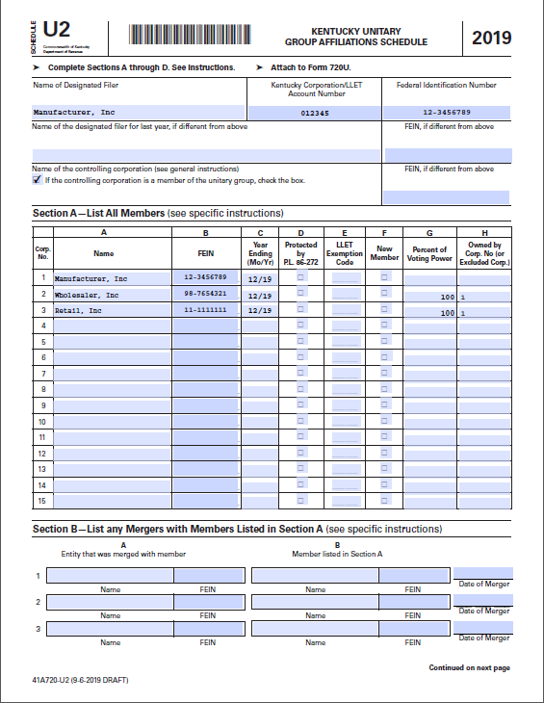

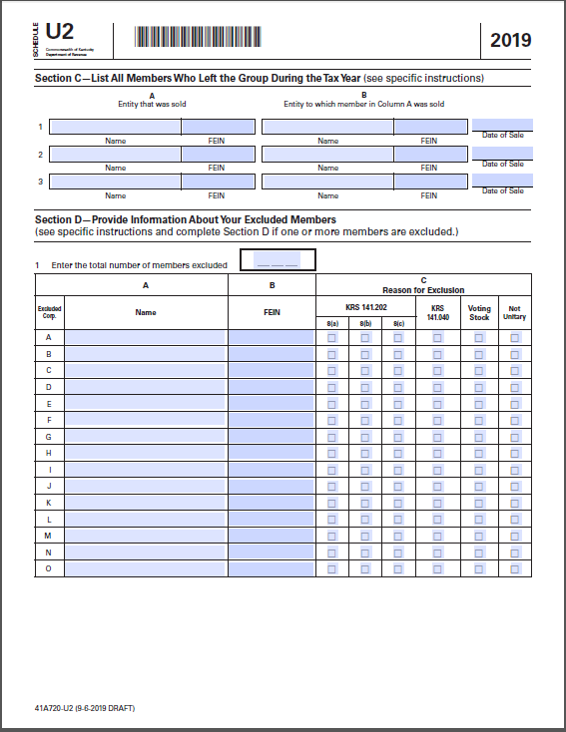

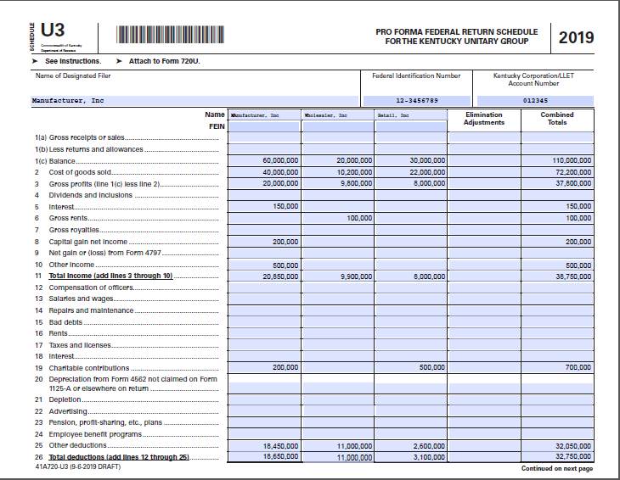

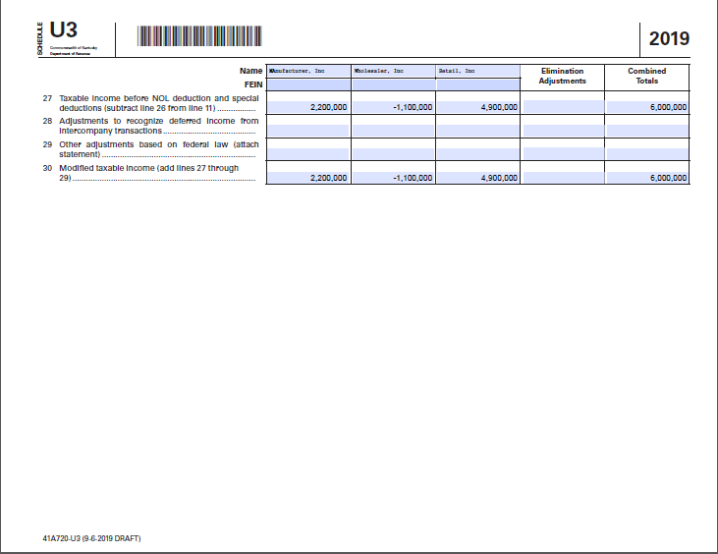

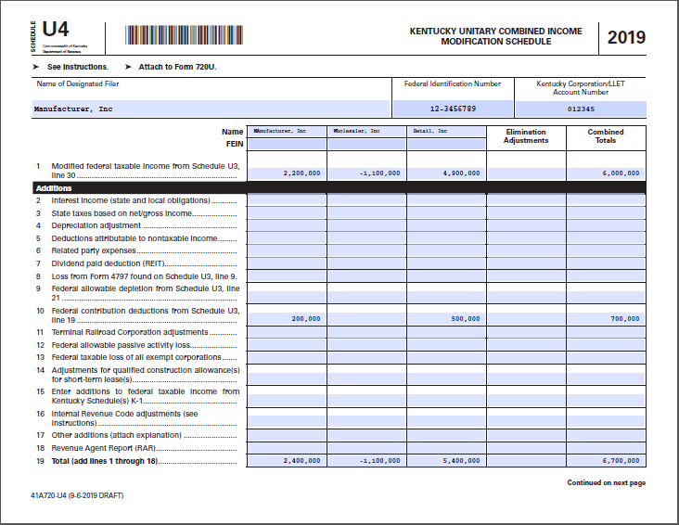

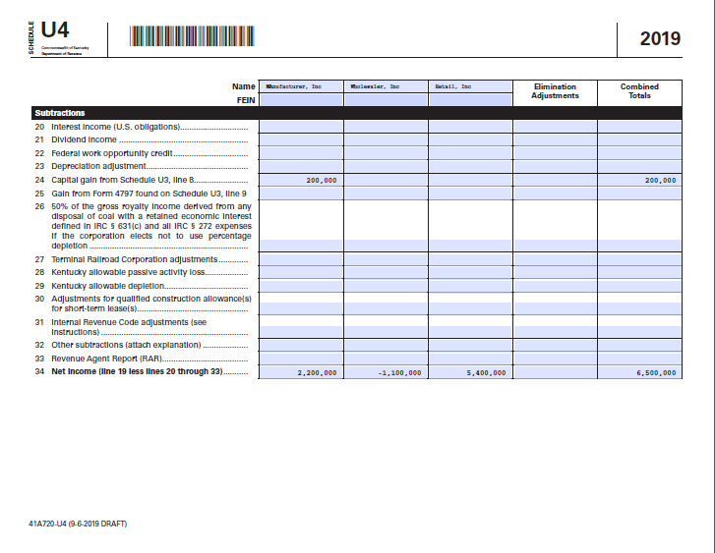

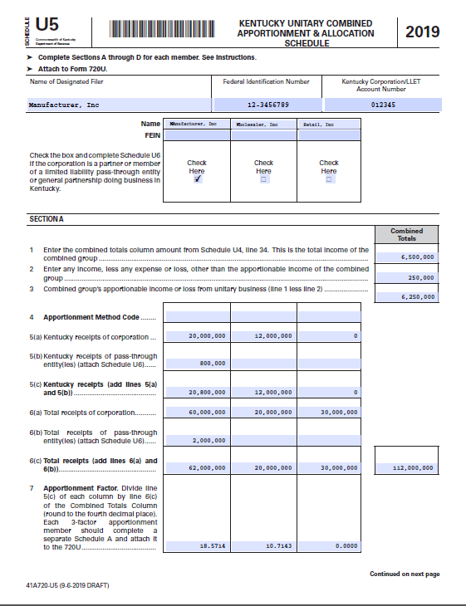

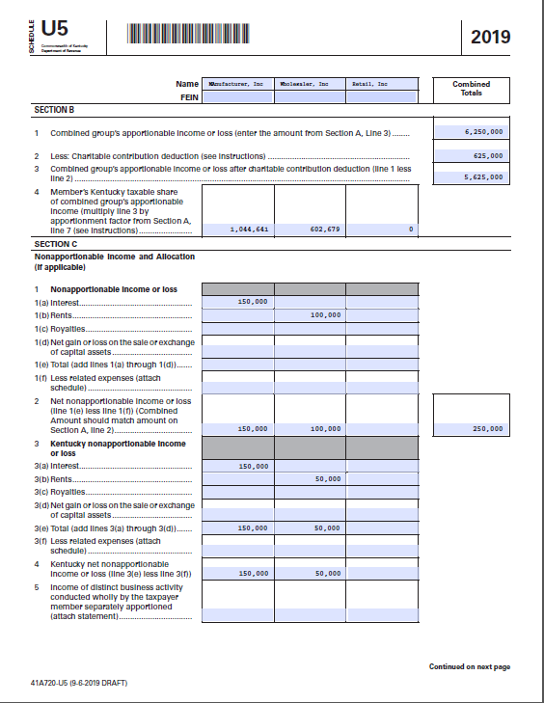

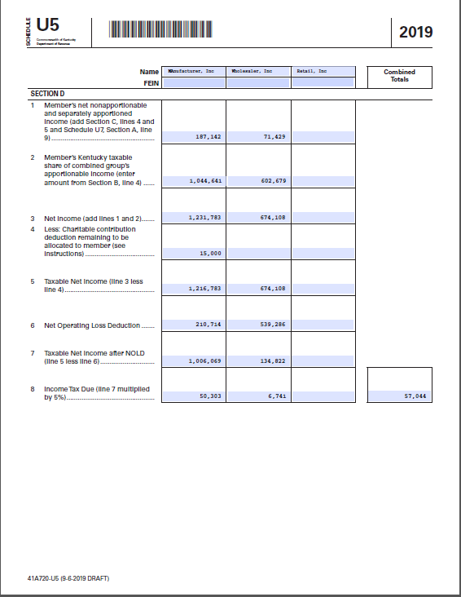







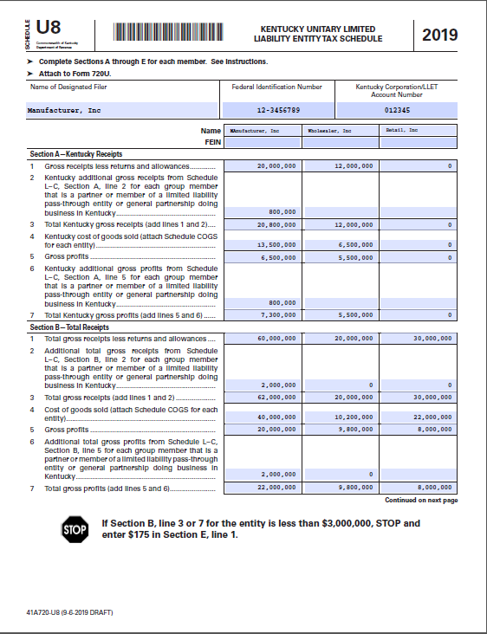

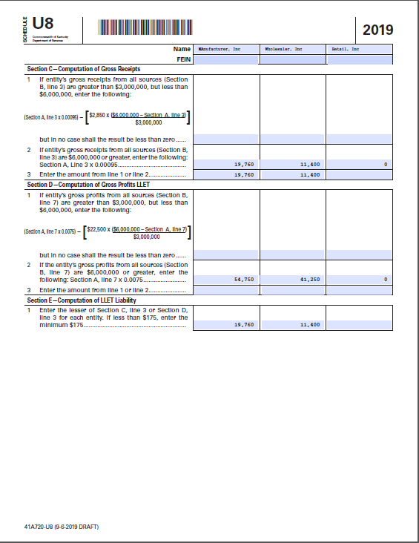

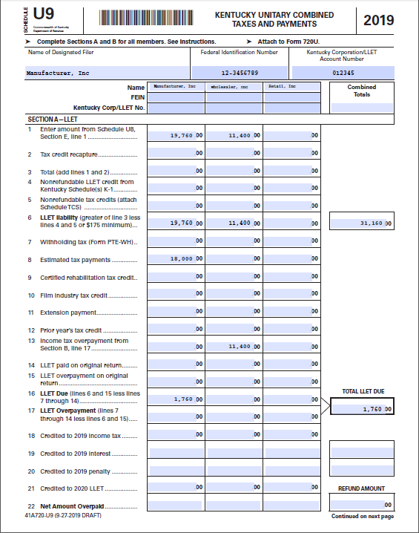

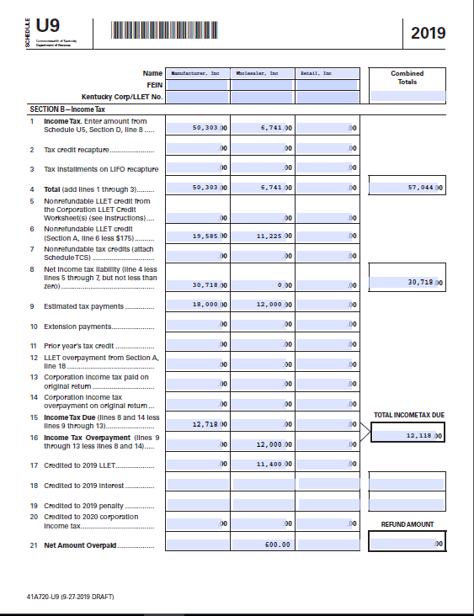

Per the U9 instructions, the combined totals column for Line 16 should reflect the net amount due for the group after subtracting net overpayments.

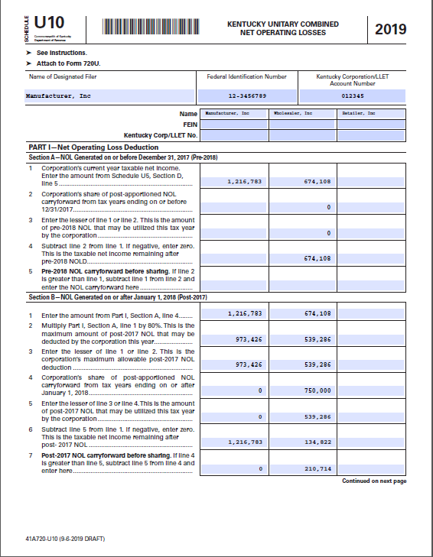

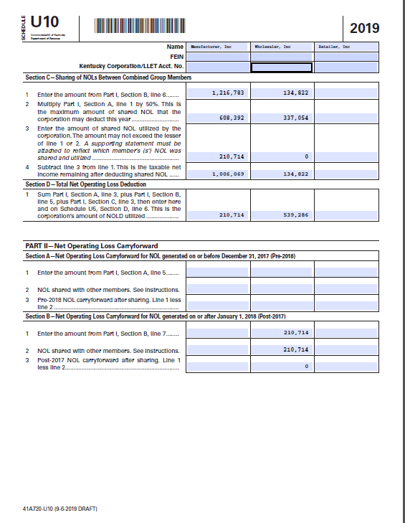

# ELECTIVE CONSOLIDATED RETURN

A multi-state corporation doing business in Kentucky may also elect to file a same-as-federal consolidated return per KRS 141.201. This means just what it says: All the companies included in a federal consolidated group (defined by IRC Sec. 1504(a)) are included in the Kentucky return. Like a unitary group, the consolidated group can include companies that do not have nexus in Kentucky. Under KRS 141.201(4)(a), a group may file a consolidated return in Kentucky even if it elects not to file as a consolidated group at the federal level. If it elects this option, the entities in the Kentucky return must be those that would have been included in the federal consolidated return had the company chosen to file consolidated at the federal level.

For an affiliated group to be entitled to file a consolidated return, all the corporations in the group must have been members of the group at some time during the tax year. In addition, each member of the group must consent to membership in the consolidated group and to the application of the consolidated return regulations. Such consent is implied by the corporation’s inclusion in a consolidated return.

A consolidated election is binding on both the corporation and the Department of Revenue for a period of 48 months. The election cannot be revoked prior to the expiration of the election period unless the consolidated group ceases to exist, in accordance with 26 USC §1504.

## **Elective Consolidated vs. Combined**

There are important differences between an elective consolidated return and a combined unitary return. The most important distinction is that with an elective consolidated return the group “shall be treated for all purposes as a single corporation” [KRS 141.201(4)(b)]. This contrasts with the emphasis on respecting the “separate identities” of the entities included in a combined return [KRS141.202(4)]. Thus with an elective consolidated return, there is one apportionment factor calculated for the group; tax credits, NOLs, and other tax attributes can be shared among members of the group (with some exceptions); and all intercompany transactions are eliminated when calculating the group’s net income.

Another important difference is that the criteria for inclusion in a consolidated group is whether a subsidiary is at least 80% owned (directly or indirectly) by a common parent. Unlike a combined return, there is no requirement that the companies in the group be involved in the same unitary business.

The following table summarizes the major differences and similarities in terminology and procedures between elective consolidated and combined unitary returns.

|  |  |  |
| --- | --- | --- |
|  | **Elective Consolidated** | **Combined Unitary** |
| Terminology | “Affiliated group”  “Consolidated group”  “Consolidated return” | “Combined group”  “Unitary group”  “Combined Report” or “Combined Return” |
| Criteria for inclusion | At least 80% ownership; only C-Corporations | Participates in the unitary business; “commonly controlled” (more than 50% ownership); only C-corporations |
| Filing entity | Common parent | Designated filer |
| Apportionment factor | Single group factor | Separate entity factors |
| Sharing of tax credits and other tax attributes | Yes | No |
| Sharing of NOLs | Yes* | Yes** |
| Intercompany eliminations | Yes | Yes |
| All group members have KY nexus | Not necessary | Not necessary |

*Subject to SRLY rules and IRC Sec. 172 limits (see below).

**Subject to sharing limitations [see KRS 141.202(5)(c)] and IRC Sec. 172 limits.

## **Apportionment**

The same rules regarding market-based sourcing, single receipts factor apportionment (except for providers), and the calculation of the receipts factor apply to elective consolidated returns and to combined returns (see pages 9-10). Unlike a combined return, however, a consolidated group generally calculates one apportionment factor for all members of the group and applies that ratio to consolidated group income to calculate its Kentucky taxable income. For an elective consolidated return, the basic apportionment calculation per KRS 141.120(9) is:

Consolidated Group Gross Receipts in Kentucky

Consolidated Group Gross Receipts Everywhere

However, if an affiliated group includes both providers and non-providers, the group will have to utilize two apportionment factor calculations. Members that are providers apportion income using the three-factor formula per KRS 141.121(3) and KRS 141.901. Non-providers apportion income based on a single receipts factor per KRS 141.120(9).

**Example: Consolidated group apportionment: Providers and non-providers**

The consolidated group consists of Parent and Subs A, B, and C. Subs B and C are providers. Parent and Sub A are not providers.

|  |  |  |  |
| --- | --- | --- | --- |
| **Non-Providers** | **Parent** | **Sub A** | **Sub-group totals** |
| Income (after eliminations) | $100,000 | $50,000 | $150,000 |
| KY Receipts | $500,000 | $250,000 | $750,000 |
| Receipts Everywhere | $1,000,000 | $350,000 | $1,350,000 |
| Apportionment Factor |  |  | 56% |
| Sub-Group Apportioned Income |  |  | $83,333 |
|  |  |  |  |
| **Providers** | **Sub B** | **Sub C** |  |
| Income (after eliminations) | $25,000 | $25,000 | $50,000 |
| KY Receipts | $100,000 | $120,000 | $220,000 |
| Receipts Everywhere | $200,000 | $200,000 | $400,000 |
| Receipts Factor |  |  | 55% |
| Receipts Factor x 2 |  |  | 110% |
|  |  |  |  |
| KY Property | $200,000 | $100,000 | $300,000 |
| Property Everywhere | $1,000,000 | $1,500,000 | $2,500,000 |
| Property factor |  |  | 12% |
|  |  |  |  |
| KY Payrolls | $300,000 | $250,000 | $550,000 |
| Payrolls Everywhere | $1,500,000 | $750,000 | $2,250,000 |
| Payroll factor |  |  | 24% |
|  |  |  |  |
| Apportionment factor |  |  | 37% |
| Sub-group apportioned income |  |  | $18,306 |
|  |  |  |  |
| Consolidated Group income after apportionment |  |  | $101,639 |

## **Net Operating Losses (NOLs)**

On a same-as-federal consolidated return, Kentucky net operating losses are calculated on a post-apportionment basis, using the consolidated group’s apportionment factor. As with a combined report (and a mandatory nexus return), taxpayers will have to track each entity’s NOLs separately in order to determine the portion of a group NOL carryforward that an entity can take with it if it leaves the group. Also as with combined returns, taxpayers will have to convert mandatory nexus pre-apportionment NOL carryforwards to post-apportionment NOL carryforwards for use on an elective consolidated return. Finally, Kentucky’s updated IRC conformity date of 12/31/2018 means that the NOL carryforward provisions of IRC Section 172 also apply.

* **Sharing of NOLs.** Members of an affiliated group can share net operating losses, provided that both entities were members of the consolidated group for the entire year. In addition, the entity that generated the NOL must have been doing business in Kentucky when the loss was generated. If the entity that generated the NOL was not a member of the affiliated group in the year the loss occurred, the group’s use of the loss is subject to the separate return limitation year (SRLY) rules explained below.
* **Pre-apportioned NOLs to post-apportioned NOLs.** Mandatory nexus filers calculated their Kentucky NOL adjustments and carryforwards based on pre-apportioned NOL amounts. Nexus groups that begin to file as same-as-federal consolidated groups after December 31, 2018, have to convert any pre-apportioned NOL carryforward amounts to post-apportioned amounts. To perform this conversion, the total pre-apportioned group carryforward needs to be allocated to each loss entity in the year the NOL was generated, and then apportioned to each entity based on the nexus group’s apportionment factor. The example on pages 18-20 illustrates this calculation.
* **IRC Section 172**. Kentucky’s Internal Revenue Code conformity date is December 31, 2018. By updating its conformity date, Kentucky incorporated many of the provisions of the 2017 federal Tax Cuts and Jobs Act (TCJA) into Kentucky law. The TCJA amended IRC Section 172 regarding carryforwards of NOLs. Specifically, it limited the deduction for net operating losses generated in tax years beginning on or after January 1, 2018, to 80% of taxable income, but it removed the time limit on carryforwards. NOLs may thus be carried forward indefinitely. NOLs generated in tax years ending on or before December 31, 2017, can offset up to 100% of taxable income, but carryforwards are subject to a 20-year limitation. When calculating the Kentucky NOL deduction, the year in which a loss was generated will determine how much income can be offset and how long NOLs can be carried forward.

## **Consolidated Loss Limitation Rules**

One of the benefits of filing an elective consolidated return is that the profitable members of the affiliated group can have their profits and tax liability offset by losses and unused credits of a non-profitable member of the group. Without any safeguards, an affiliated group with large profits could simply go out and acquire a failing corporation with substantial accumulated loss and credit carryovers, include it in the consolidated return, and derive undeserved benefits from these so-called *tax attributes*. In order to prevent this, the consolidated return regulations contain three provisions that limit an affiliated group’s use of a new member’s pre-affiliation tax attributes.

* **Separate Return Limitation Year (SRLY) Rules.** A separate return limitation year (SRLY) is a year when the corporation was not a member of the affiliated group. This rule limits the amount of a deduction, loss, or credit that can be utilized against the affiliated group’s income in the consolidated return year if the tax attribute originated in a year when the member corporation filed a separate return or was a member of a different affiliated group. The SRLY rules apply to NOLs, net capital losses, investment credits, and foreign tax credits.

A key point of the SRLY rules is that carryovers of certain tax attributes from a separate-return year are allowed for a consolidated return year only to the extent that they would have been allowed had the member filed a separate return. If an entity brought an NOL from a separate-return year into a consolidated filing year, for example, the NOL could only be used to offset group income up to the amount of income contributed by the formerly separate member. See the example below.

Two exceptions apply. First, the formerly separate member that generated the NOL (or other tax attribute) had to have Kentucky nexus in the year that the loss originated. Second, the SRLY rules do not apply to the common parent corporation. Under the so-called “lonely parent” rule, a parent with no subsidiaries is nonetheless treated as the common parent of a consolidated group.

**Example: Applying the SRLY Rules**

In Year 1, Parent Co. owned 50% of Sub A and 100% of Subs B and C. All entities were doing business in Kentucky in Year 1. Parent, Sub B, and Sub C filed a mandatory nexus return in Year 1. Sub A filed a separate-entity return in Year 1.

In Year 2, Parent increased its ownership of Sub A to 100%. The group elected to file a same-as-federal consolidated return that included Parent Co, Sub A, Sub B, and Sub C. Income and apportionment figures for Year 1 and Year 2 are shown below.

Year 1: Year 2:

Sub A income (loss): ($2,000) Consolidated group

Nexus group Sub A income (loss): $ 5,000

Parent income (loss): $20,000 Parent income (loss): $25,000

Sub B income (loss): $10,000 Sub B income (loss): ($15,000)

Sub C income (loss): $10,000 Sub C income (loss): $ 5,000

Group income: $40,000 Group income: $20,000

Apportionment factor: 20% Apportionment factor: 15%

Taxable Income: $ 8,000 Taxable income: $ 3,000

KNOLD: n/a KNOLD: $ 750**

Taxable income after NOL: $ 8,000 Taxable income after NOL: $ 2,250

** SRLY Rule limits utilization of Sub A NOL from Year 1 to Sub A contribution to net income (after apportionment): $5,000 x 15% = $750. Sub A NOL remaining: $2000 - $750 = $1,250.

* **Built-In Deduction.** A “built-in” deduction is a deduction or loss that is accrued in a separate-return year and carried into a consolidated return year. This occurs when the assets of a newly acquired corporation are retained during the acquisition, and the fair market value of the assets is lower than the assets’ adjusted basis recorded on the books of the acquired corporation. The economic loss (the difference between the fair market value and the adjusted basis of the assets) will not be realized until the assets are sold or otherwise disposed. The unrealized economic loss constitutes the “built-in” deduction.

When the assets are sold, the portion of the realized loss that was accrued before the date of acquisition can only be used to offset group income up to the amount of income contributed by the member that disposed of the asset. This is similar to the SRLY rules noted above. If the loss exceeds the amount of income, the excess can be carried forward. Without this rule, a parent corporation could acquire a subsidiary with overvalued assets, sell the assets at a loss, and then use those realized losses to offset group income, even though the losses did not result from any event that occurred while the acquired corporation was a member of the affiliated group.

* **Section 382 limitations.** When any one or more 5% shareholders (by value) of a company increase their holdings over a three-year testing period by more than 50 percentage points, the limitations of IRC Section 382 are triggered. These limitations affect the use of losses from a newly acquired company by a consolidated group. The limitation is calculated based on the fair market value of the acquired corporation multiplied by the highest federal long-term tax-exempt interest rate. See 26 CFR 1.1502-94.

## **Elective Consolidated Filing Rules**

* **Form 722.**The election to file as a consolidated group is made by filing Kentucky Form 722. Form 722 must be filed with the return on or before the due date (or the extended date) of the first tax year that the taxpayer files as a consolidated group. The election is binding for *48 months (4 years*) and Form 722 must be attached to the return in each subsequent year that the election is effective. A taxpayer may file a new Form 722 prior to the expiration of the previous election period, but the new election period would not begin until after the cessation of the previous election period.
* **Failure to file Form 722.** A taxpayer that does not file Form 722 has not made an election. Moreover, continuing to file on a consolidated basis after the expiration of an election period does not indicate that the taxpayer intends to begin a new election period.
* **Newly acquired corporations.** If a company is acquired during a tax year when a consolidated election is in effect, the newly acquired corporation must join the existing group’s election and adopt the common parent’s tax year.
* **Common parent corporation.** The common parent of the affiliated group must file the consolidated return for the group, even if the common parent does not have nexus in Kentucky. This requires the common parent to obtain a Kentucky Tax ID.
* **Consolidated group ceases to exist.** An affiliated group remains in existence as long as the common parent is the common parent and at least one includible member remains affiliated with it. A group ceases to exist—and thus the election period terminates—when the common parent ceases to be the common parent. See IRC Sec.1504.

**Example: Consolidated group ceases to exist**

Mom & Pop’s Grocery Store is a parent corporation with two other locations that are listed as subsidiaries in their affiliated group. They file elective consolidated returns and have a current election that is set to expire at the end of Year 4. However, because of problems in the larger economy, Mom & Pop’s was bought out by a larger corporation at the end of Year 2, thus changing the structure of the affiliated group so that Mom & Pop are no longer considered the parent corporation. The consolidated election becomes null and void, and the new parent corporation must file a new election if it wishes to file on a consolidated basis.

* **Common tax year.** Each member of the affiliated group must utilize the common parent’s tax year. However, members of the group are permitted to use different methods of accounting, if they so choose.
* **Deferred intercompany transactions.** Federal regulation 26 CFR 1.1502-13 allows consolidated group members to defer gains on intercompany transactions when certain conditions are met. Kentucky law does not allow this same treatment. As a result, sometimes a company has recognized gain in Kentucky before the gain is recognized at the federal level. Therefore, when the federal gain is recognized (usually by a sale to an unrelated party), the gain or loss should be adjusted for Kentucky purposes to reflect the prior reporting of the transaction. See 103 KAR 16:200 §4.

**Example: Deferred Intercompany Transaction**

One member of a consolidated group sells a machine with a basis of $800 to another member for $1,000. For Kentucky purposes, the group would recognize the $200 gain in the year the sale occurred.

For federal purposes, however, the buying company could choose to depreciate the machine on a straight-line basis for ten years. The selling company would recognize $20 (one tenth of $200) each year on its Schedule D as ordinary income.

Department auditors should establish the nature of the gains reported on Schedule D. In this case, the auditor would adjust the amount of gain to reflect the entire $200 for Kentucky purposes in the year of the sale and not allow the deferral. The auditor should also remember to adjust the amounts reported on Schedule D in subsequent years.

# APPENDIX

**141.202 Requirement of taxpayer engaged in a unitary business with one or more other corporations to file a combined report -- Administrative regulations -- Taxable years beginning on or after January 1, 2019.**

1. This section shall apply to taxable years beginning on or after January 1, 2019.
2. As used in this section:
   1. "Combined group" means the group of all corporations whose income and apportionment factors are required to be taken into account as provided in subsection (3) of this section in determining the taxpayer's share of the net income or loss apportionable to this state. A combined group shall include only corporations, the voting stock of which is more than fifty percent (50%) owned, directly or indirectly, by a common owner or owners;
   2. "Corporation" has the same meaning as in KRS 141.010, including an organization of any kind treated as a corporation for tax purposes under KRS 141.040, wherever located, which if it were doing business in this state would be a taxpayer, and the business conducted by a pass-through entity which is directly or indirectly held by a corporation shall be considered the business of the corporation to the extent of the corporation's distributive share of the pass-through entity income, inclusive of guaranteed payments;
   3. "Doing business in a tax haven" means being engaged in activity sufficient for that tax haven jurisdiction to impose a tax under United States constitutional standards;
   4. 1. "Tax haven" means a jurisdiction that, during the taxable year has no or nominal effective tax on the relevant income and:
      1. Has laws or practices that prevent effective exchange of information for tax purposes with other governments on taxpayers benefitting from the tax regime;
      2. Has a tax regime which lacks transparency. A tax regime lacks transparency if the details of legislative, legal, or administrative provisions are not open and apparent or are not consistently applied among similarly situated taxpayers, or if the information needed by tax authorities to determine a taxpayer's correct tax liability, such as accounting records and underlying documentation is not adequately available;
      3. Facilitates the establishment of foreign-owned entities without the need for a local substantive presence or prohibits these entities from having any commercial impact on the local economy;
      4. Explicitly or implicitly excludes the jurisdiction's resident taxpayers from taking advantage of the tax regime's benefits or prohibits enterprises that benefit from the regime from operating in the jurisdiction's domestic market; or
      5. Has created a tax regime which is favorable for tax avoidance, based upon an overall assessment of relevant factors, including whether the jurisdiction has a significant untaxed offshore financial or other services sector relative to its overall economy.

2. "Tax haven" does not include a jurisdiction that has entered into a comprehensive income tax treaty with the United States, which the Secretary of the Treasury has determined is satisfactory for purposes of Section 1(h)(11)(C)(i)(II) of the Internal Revenue Code;

* 1. "Taxpayer" means any corporation subject to the tax imposed under this chapter;
  2. "Unitary business" means a single economic enterprise that is made up either of separate parts of a single corporation or of a commonly controlled group of corporations that are sufficiently interdependent, integrated, and interrelated through their activities so as to provide a synergy and mutual benefit that produces a sharing or exchange of value among them and a significant flow of value to the separate parts. For purposes of this section, the term "unitary business" shall be broadly construed, to the extent permitted by the United States Constitution; and
  3. "United States" means the fifty (50) states of the United States, the District of Columbia, and United States' territories and possessions.

1. (a) Except as provided in KRS 141.201, a taxpayer engaged in a unitary business with one (1) or more other corporations shall file a combined report which includes the income, determined under subsection (5) of this section, and the apportionment fraction, determined under KRS 141.120 and paragraph (d) of this subsection, of all corporations that are members of the unitary business, and any other information as required by the department. The combined report shall be filed on a waters-edge basis under subsection (8) of this section.
   1. The department may, by administrative regulation, require that the combined report include the income and associated apportionment factors of any corporations that are not included as provided by paragraph (a) of this subsection, but that are members of a unitary business, in order to reflect proper apportionment of income of the entire unitary businesses. Authority to require combination by administrative regulation under this paragraph includes authority to require combination of corporations that are not, or would not be combined, if the corporation were doing business in this state.
   2. In addition, if the department determines that the reported income or loss of a taxpayer engaged in a unitary business with any corporation not included as provided by paragraph (a) of this subsection represents an avoidance or evasion of tax by the taxpayer, the department may, on a case-by-case basis, require all or any part of the income and associated apportionment factors of the corporation be included in the taxpayer's combined report.
   3. With respect to the inclusion of associated apportionment factors as provided in paragraph (a) of this subsection, the department may require the inclusion of any one (1) or more additional factors which will fairly represent the taxpayer's business activity in this state, or the employment of any other method to effectuate a proper reflection of the total amount of income subject to apportionment and an equitable allocation and apportionment of the taxpayer's income.
   4. A unitary business shall consider the combined gross receipts and combined income from all sources of all members under subsection (8) of this section, including eliminating entries for transactions among the members under subsection (8)(e) of this section.
   5. Notwithstanding paragraphs (a) to (e) of this subsection, a consolidated return may be filed as provided in KRS 141.201 if the taxpayer makes an election according to KRS 141.201.
2. The use of a combined report does not disregard the separate identities of the taxpayer members of the combined group. Each taxpayer member is responsible for tax based on its taxable income or loss apportioned or allocated to this state, which shall include, in addition to the other types of income, the taxpayer member's share of apportionable income of the combined group, where apportionable income of the combined group is calculated as a summation of the individual net incomes of all members of the combined group. A member's net income is determined by removing all but apportionable income, expense, and loss from that member's total income as provided in subsection (5) of this section.
3. (a) Each taxpayer member is responsible for tax based on its taxable income or loss apportioned or allocated to this state, which shall include:
   * 1. Its share of any income apportionable to this state of each of the combined groups of which it is a member, determined under subsection (6) of this section;
     2. Its share of any income apportionable to this state of a distinct business activity conducted within and without the state wholly by the taxpayer member, determined under KRS 141.120;
     3. Its income from a business conducted wholly by the taxpayer member

entirely within the state;

* + 1. Its income sourced to this state from the sale or exchange of capital or assets, and from involuntary conversions, as determined under subsection (8)(k) of this section;
    2. Its nonapportionable income or loss allocable to this state, determined under KRS 141.120;
    3. Its income or loss allocated or apportioned in an earlier year, required to be taken into account as state source income during the income year, other than a net operating loss; and
    4. Its net operating loss carryover.
  1. No tax credit or post-apportionment deduction earned by one (1) member of the group, but not fully used by or allowed to that member, may be used in whole or in part by another member of the group or applied in whole or in part against the total income of the combined group.
  2. If the taxable income computed pursuant to KRS 141.039 results in a net loss for a taxpayer member of the combined group, that taxpayer member has a Kentucky net operating loss, subject to the net operating loss limitations and carry forward provisions of KRS 141.011. No prior year net operating loss carryforward shall be available to entities that were not doing business in this state in the year in which the loss was incurred. A Kentucky net operating loss carryover incurred by a taxpayer member of a combined group shall be deducted from income or loss apportioned to this state pursuant to this section as follows:

1. For taxable years beginning on or after the first day of the initial taxable year for which a combined unitary tax return is required under this section, if the computation of a combined group's Kentucky net income before apportionment to this state results in a net operating loss, a taxpayer member of the group may carry over its share of the net operating loss as apportioned to this state, as calculated under this section and in accordance with KRS 141.120 or 141.121, and it shall be deductible from a taxpayer member's apportioned net income derived from the unitary business in a future tax year to the extent that the carryover and deduction is otherwise consistent with KRS 141.011;
2. Where a taxpayer member of a combined group has a Kentucky net operating loss carryover derived from a loss incurred by a combined group in a tax year beginning on or after the first day of the initial tax year for which a combined unitary tax return is required under this section, then the taxpayer member may share the net operating loss carryover with other taxpayer members of the combined group if the other taxpayer members were members of the combined group in the tax year that the loss was incurred. Any amount of net operating loss carryover that is deducted by another taxpayer member of the combined group shall reduce the amount of net operating loss carryover that may be carried over by the taxpayer member that originally incurred the loss;
3. Where a taxpayer member of a combined group has a net operating loss carryover derived from a loss incurred in a tax year prior to the initial tax year for which a combined unitary tax return is required under this section, the carryover shall remain available to be deducted by that taxpayer member and any other taxpayer members of the combined group, but in no case shall the deduction reduce any taxpayer member's Kentucky apportioned taxable income by more than fifty percent (50%) in any taxable year, other than the taxpayer member that originally incurred the net operating loss, in which case no limitation is provided except as provided by Section 172 of the Internal Revenue Code. Any net operating loss carryover that is not utilized in a particular taxable year shall be carried over by the taxpayer member that generated the loss and utilized in the future consistent with the limitations of this subparagraph; or
4. Where a taxpayer member of a combined group has a net operating loss carryover derived from a loss incurred in a tax year during which the taxpayer member was not a taxpayer member of the combined group, the carryover shall remain available to be deducted by that taxpayer member or other taxpayer members, but in no case shall the deduction reduce any taxpayer member's Kentucky apportioned taxable income by more than fifty percent (50%) in any taxable year, other than the taxpayer member that originally incurred the net operating loss, in which case no limitation is provided except as provided by Section 172 of the Internal Revenue Code. Any net operating loss carryover that is not utilized in a particular taxable year, shall be carried over by the taxpayer member that generated the loss and utilized in the future consistent with the limitations of this subparagraph.
5. The taxpayer's share of the business income apportionable to this state of each combined group of which it is a member shall be the product of:
   * 1. The apportionable income of the combined group, determined under

subsection (7) of this section; and

* + 1. The taxpayer member's apportionment fraction, determined under KRS 141.120, including in the sales factor numerator the taxpayer's sales associated with the combined group's unitary business in this state, and including in the denominator the sales of all members of the combined group, including the taxpayer, which sales are associated with the combined group's unitary business wherever located. The sales of a pass-through entity shall be included in the determination of the partner's apportionment percentage in proportion to a ratio, the numerator of which is the amount of the partner's distributive share of the pass-through entity's unitary income included in the income of the combined group as provided in subsection (8) of this section and the denominator of which is the amount of pass-through entity's total unitary income.

1. The apportionable income of a combined group is determined as follows:
   * 1. The total income of the combined group is the sum of the income of each member of the combined group determined under federal income tax laws, as adjusted for state purposes, as if the member were not consolidated for federal purposes; and
     2. From the total income of the combined group determined under subsection (8) of this section, subtract any income and add any expense or loss, other than the apportionable income, expense, or loss of the combined group.
2. To determine the total income of the combined group, taxpayer members shall take into account all or a portion of the income and apportionment factor of only the following members otherwise included in the combined group as provided in subsection (3) of this section:
   1. The entire income and apportionment percentage of any member, incorporated in the United States or formed under the laws of any state, the District of Columbia, or any territory or possession of the United States, that earns less than eighty percent (80%) of its income from sources outside of the United States, the District of Columbia, or any territory or possession of the United States;
   2. Any member that earns more than twenty percent (20%) of its income, directly or indirectly, from intangible property or service related activities that are deductible against the apportionable income of other members of the combined group, to the extent of that income and the apportionment factor related to that income. If a non-United States corporation is includible as a member in the combined group, to the extent that the non-United States corporation's income is excluded from United States taxation pursuant to the provisions of a comprehensive income tax treaty, the income or loss is not includible in the combined group's net income or loss. The member's expenses or apportionment factors attributable to income that is excluded from United States taxation pursuant to the provisions of a comprehensive income tax treaty are not to be included in the combined report;
   3. The entire income and apportionment factor of any member that is doing business in a tax haven. If the member's business activity within a tax haven is entirely outside the scope of the laws, provisions, and practices that cause the jurisdiction to meet the definition established in subsection (2)(d) of this section, the activity of the member shall be treated as not having been conducted in a tax haven;
   4. If a unitary business includes income from a pass-through entity, the income to be included in the total income of the combined group shall be the member of the combined group's direct and indirect distributive share of the pass-through entity's unitary income;
   5. Income from an intercompany transaction between members of the same combined group shall be deferred in a manner similar to 26 C.F.R. 1.1502-13. Upon the occurrence of any of the following events, deferred income resulting from an intercompany transaction between members of a combined group shall be restored to the income of the seller, and shall be apportionable income earned immediately before the event:
      1. The object of a deferred intercompany transaction is:
         1. Resold by the buyer to an entity that is not a member of the combined group;
         2. Resold by the buyer to an entity that is a member of the combined group for use outside the unitary business in which the buyer and seller are engaged; or
         3. Converted by the buyer to a use outside the unitary business in which the buyer and seller are engaged; or
      2. The buyer and seller are no longer members of the same combined group, regardless of whether the members remain unitary;
3. A charitable expense incurred by a member of a combined group shall, to the extent allowable as a deduction provided by Section 170 of the Internal Revenue Code, be subtracted first from the apportionable income of the combined group, subject to the income limitations of that section applied to the entire apportionable income of the group, and any remaining amount shall then be treated as a nonapportionable expense allocable to the member that incurred the expense, subject to the income limitations of that section applied to the nonapportionable income of that specific member. Any charitable deduction disallowed under this paragraph, but allowed as a carryover deduction in a subsequent year, shall be treated as originally incurred in the subsequent year by the same member, and this paragraph shall apply in the subsequent year in determining the allowable deduction in that year;
4. Gain or loss from the sale or exchange of capital assets, property described by Section 1231(a)(3) of the Internal Revenue Code, and property subject to an involuntary conversion shall be removed from the total separate net income of each member of a combined group and shall be apportioned and allocated as follows:
   1. For each class of gain or loss, including short-term capital, long-term capital, Internal Revenue Code Section 1231, and involuntary conversions, all members' gain and loss for the class shall be combined, without netting between the classes, and each class of net gain or loss separately apportioned to each member using the member's apportionment percentage determined under subsection (6) of this section;
   2. Each taxpayer member shall then net its apportioned business gain or loss for all classes, including any apportioned gain and loss from other combined groups, against the taxpayer member's nonapportionable gain and loss for all classes allocated to this state, using the rules of Sections 1231 and 1222 of the Internal Revenue Code, without regard to any of the taxpayer member's gains or losses from the sale or exchange of capital assets, Internal Revenue Code Section 1231 property, and involuntary conversions which are nonapportionable items allocated to another state;
   3. Any resulting state source income or loss, if the loss is not subject to the limitations of Section 1211 of the Internal Revenue Code, of a taxpayer member produced by the application of subparagraphs 1. and 2. of this paragraph shall then be applied to all other state source income or loss of that member; and
   4. Any resulting state source loss of a member that is subject to the limitations of Section 1211 of the Internal Revenue Code shall be carried forward by that member, and shall be treated as state source short-term capital loss incurred by that member for the year for which the carryover applies; and
5. Any expense of one (1) member of the unitary group which is directly or indirectly attributable to the nonapportionable or exempt income of another member of the unitary group shall be allocated to that other member as corresponding nonapportionable or exempt expense, as appropriate.

(9) (a) As a filing convenience, and without changing the respective liability of the group members, members of a combined reporting group shall annually designate one (1) taxpayer member of the combined group to file a single return in the form and manner prescribed by the department, in lieu of filing their own respective returns.

(b) The taxpayer member designated to file the single return shall consent to act as surety with respect to the tax liability of all other taxpayers properly included in the combined report, and shall agree to act as agent on behalf of those taxpayers for the taxable year for matters relating to the combined report. If for any reason the surety is unwilling or unable to perform its responsibilities, tax liability may be assessed against the taxpayer members.

**Effective:** June 27, 2019

**History:** Amended 2019 Ky. Acts ch. 196, sec. 5, effective June 27, 2019. -- Created 2018 Ky. Acts ch. 207, sec. 120, effective April 27, 2018.

**Legislative Research Commission Note** (6/27/2019). This statute was amended in 2019 Ky. Acts ch. 151, sec. 48 (HB 354) and ch. 196, sec. 5 (HB 458). Although HB 354 was enacted, 2019 Ky. Acts ch. 196, sec. 16 (HB 458) repealed certain sections of that prior Act, including Section 48, and directed the Reviser of Statutes to not codify them. Therefore, the amendment to this statute in 2019 Ky. Acts ch. 151, sec. 48, was not codified.

**Legislative Research Commission Note** (4/27/2018). Pursuant to 2018 Ky. Acts ch. 207, sec. 154, the provisions created for this statute in that Act apply to taxable years beginning on or after January 1, 2019.

103 KAR 16:400. Combined Unitary Kentucky corporation income tax return.

RELATES TO: KRS 141.120, 141.121, 141.202

STATUTORY AUTHORITY: KRS 131.130(1), 141.050(4)

NECESSITY, FUNCTION, AND CONFORMITY: KRS 141.202 establishes the general rules for combined unitary reporting in Kentucky. KRS 131.130(1) authorizes the Department of Revenue to promulgate administrative regulations necessary to administer and enforce Kentucky's tax laws. KRS 141.050(4) requires the Department of Revenue to promulgate administrative regulations and rules necessary for the proper administration of KRS Chapter 141. This administrative regulation establishes terms and procedures required for the implementation of combined unitary reporting in KRS 141.202.

Section 1. Definitions. (1) "Combined group" is defined by KRS 141.202(2)(a).

(2) "Corporation" is defined by KRS 141.202(2)(b).

(3) "Designated Filer" means the taxpayer member of the combined group annually designated per KRS 141.202(9) to file the return.

(4) "Person" is defined by KRS 141.010(24).

(5) "Taxpayer" is defined by KRS 141.202(2)(e).

(6) "Unitary Business" is defined by KRS 141.202(2)(f).

Section 2. Fifty (50) Percent Ownership Test. Separate corporations may be part of a combined group only if they meet the fifty (50) percent ownership test in KRS 141.202(2)(a).

(1) The fifty (50) percent test shall be satisfied in the following circumstances:

(a) A parent corporation and one (1) or more corporations or chains of corporations which are connected through voting stock ownership with the parent, whether the ownership is direct or indirect, but only if:

1. The parent owns more than fifty (50) percent of the outstanding voting stock of at least one (1) corporation; and

2. If applicable, more than fifty (50) percent of the outstanding voting stock of each of the corporations, other than the parent, is owned by the parent, one (1) or more corporations owned by the parent as described in subsection (1) of this section, or one (1) or more corporations that satisfy the conditions of this subparagraph;

(b) Any two (2) or more corporations, if over fifty (50) percent of the outstanding voting stock of each of the corporations is owned, or indirectly owned, by the same person; or

(c) Any two (2) or more corporations, over fifty (50) percent of whose voting stock is cumulatively owned (without regard to the indirect ownership rules described in subsection (2) of this section) by, or for the benefit of, members of the same family. Members of the same family shall be limited to an individual, his or her spouse, parents, brothers or sisters, grandparents, children and grandchildren, and their respective spouses.

(2) Except as otherwise provided in this section, voting stock is "owned" if title to the stock is directly held or if the voting stock is indirectly owned. The stock attribution rules of Section 318(a) of the Internal Revenue Code, 26 U.S.C. 318(a), shall be used to determine if the voting stock is indirectly owned except if a person has an option to acquire stock or other ownership interests in an entity, the stock or ownership interests are not considered owned by the person unless the department determines it to be necessary to prevent tax avoidance.

(3) In determining ownership, effective control over election of the board of directors shall be considered. For example, a group of shareholders acting in concert who collectively own over fifty (50) percent of the voting stock of each of two (2) or more corporations shall be considered to be common owners of more than fifty (50) percent of the voting stock of each of those corporations. "Voting stock" refers only to those shares of voting stock having the power to elect the corporation’s board of directors. If the power otherwise held in corporate stock to vote the membership of the board is transferred to another, other than a transfer of proxy only, the holder of that power shall be considered to be the owner of that stock to the exclusion of the transferor of that power.

(4) In addition to the tests in subsection (1) of this section, the department may consider any other circumstance that tends to demonstrate that the fifty (50) percent direct or indirect common ownership test was met, or was not met.

(5) Membership in a combined group shall be treated as terminated in any year, or fraction thereof, in which the conditions of subsection (1) of this section are not met, except as follows:

(a) If stock of a corporation is sold, exchanged, or otherwise disposed of, the membership of a corporation in a combined group shall not be terminated if the requirements of subsection (1) of this section are again met immediately after the sale, exchange, or disposition.

(b) The department may treat the combined group as remaining in place if the conditions of subsection (1) of this section are again met within a period not to exceed two (2) years.

Section 3. Unitary Business Principle. (1) The concept of a Unitary Business.

(a) The flow of value to an entity located in this state that comes from being part of a unitary business conducted both within and without this state is what provides the constitutional due process "definite link and minimum connection" necessary for this state to apportion apportionable income of the unitary business, even if that income arises in part from activities conducted outside the state.

(b) This sharing or exchange of value may also be described as:

1. Requiring that the operation of one (1) part of the business be dependent upon, or contribute to, the operation of another part of the business: or

2. If the activities of one (1) business either contribute to the activities of another business or are dependent upon the activities of another business, those businesses are part of a unitary business.

(2) Constitutional requirement for a Unitary Business.

(a) The sharing or exchange of value described in KRS 141.202(2)(f) and subsection (1) of this section that defines the scope of a unitary business shall require more than the mere flow of funds arising out of a passive investment or from the financial strength contributed by a distinct business undertaking that has no operational relationship to the unitary business.

(b) In this state, the unitary business principle shall be applied to the full extent allowed by the U.S. Constitution. The unitary business principle shall not be applied to result in the combination of business activities or entities under circumstances where, if it were adverse to the taxpayer, the combination of the activities or entities would not be allowed by the U.S. Constitution.

(3) Separate trades or businesses conducted within a single entity. A single entity may have more than one (1) unitary business. In these cases, the apportionable income attributable to each separate unitary business as well as its non-apportionable income, which is specifically allocated, shall be determined. The apportionable income of each unitary business shall then be apportioned by a formula that takes into consideration the in-state and the out-of-state factors that relate to the respective unitary business whose income is being apportioned.

(4) Unitary Business unaffected by formal business organization. A unitary business may exist within a single entity or among a group of entities meeting the fifty (50) percent ownership test in KRS 141.202(2)(a) and in Section 2 of this administrative regulation.

Section 4. Determination of a Unitary Business. (1) A unitary business shall be characterized by significant flows of value evidenced by factors such as functional integration, centralization of management, and economies of scale. These factors provide evidence of whether the business activities operate as an integrated whole or exhibit substantial mutual interdependence. Facts suggesting the presence of these factors shall be analyzed in combination for their cumulative effect and not in isolation. A particular business operation may be suggestive of one (1) or more of the factors mentioned above.

(2) Description and illustration of functional integration, centralization of management, and economies of scale.

(a) Functional integration. Functional integration shall refer to transfers between, or pooling among, business activities that significantly affect the operation of the business activities. Functional integration shall include transfers or pooling with respect to the unitary business's products or services, technical information, marketing information, distribution systems, purchasing, and intangibles such as patents, trademarks, service marks, copyrights, trade secrets, know-how, formulas, and processes. A specific type of functional integration shall not be   
required. The following is a list of examples of business operations that may support the finding of functional integration. The order of the list does not establish a hierarchy of importance.

1. Sales, exchanges, or transfers (collectively "sales") of products, services, or intangibles between business activities may provide evidence of functional integration. The significance of the intercompany sales to the finding of functional integration shall be affected by the character of what is sold or the percentage of total sales or purchases represented by the intercompany sales. For example, sales among entities that are part of a vertically integrated unitary business are indicative of functional integration. Functional integration shall not be negated by   
the use of a readily determinable market price to effect the intercompany sales, because those sales may represent an assured market for the seller or an assured source of supply for the purchaser.

2. Common Marketing. The sharing of common marketing features among entities shall indicate functional integration if the marketing results in significant mutual advantage. Common marketing exists if a substantial portion of the entities' products, services, or intangibles are distributed or sold to a common customer, if the entities use a common trade name or other common identification, or if the entities seek to identify themselves to their customers as a member of the same enterprise. The use of a common advertising agency or a commonly owned or controlled in-house advertising office shall not by itself establish common marketing that is suggestive of functional integration. That activity, however, shall be relevant to determining the existence of economies of scale or centralization of management.

3. Transfer or Pooling of Technical Information or Intellectual Property. Transfers or pooling of technical information or intellectual property, such as patents, copyrights, trademarks and service marks, trade secrets, processes or formulas, know-how, research, or development, shall provide evidence of functional integration if the matter transferred is significant to the businesses' operations.

4. Common Distribution System. Use of a common distribution system by the entities, under which inventory control and accounting, storage, trafficking, or transportation are controlled through a common network shall provide evidence of functional integration.

5. Common Purchasing. Common purchasing of substantial quantities of products, services, or intangibles from the same source by the entities, particularly if the purchasing results in significant cost savings or if the products, services or intangibles are not readily available from other sources and are significant to each entity's operations or sales, shall provide evidence of functional integration.

6. Common or Intercompany Financing. Significant common or intercompany financing, including the guarantee by, or the pledging of the credit of, one (1) or more entities for the benefit of another entity or entities shall provide evidence of functional integration, if the financing activity serves an operational purpose of both borrower and lender. Lending which serves an investment purpose of the lender shall not necessarily provide evidence of functional integration.

(b) Centralization of Management. Centralization of management shall exist if directors, officers, or other management employees jointly participate in the management decisions that affect the respective business activities and that may also operate to the benefit of the entire economic enterprise. Centralization of management may exist whether the centralization is effected from a parent entity to a subsidiary entity, from a subsidiary entity to a parent entity, from one (1) subsidiary entity to another, from one (1) division within a single entity to another   
division within an entity, or from any combination of the foregoing. Centralization of management may exist even if day-to-day management responsibility and accountability has been decentralized, if the management has an ongoing operational role with respect to the business activities. An operational role may be effected through mandates, consensus building, or an overall operational strategy of the business, or any other mechanism that establishes joint management.

1. Facts Providing Evidence of Centralization of Management. Evidence of centralization of management shall be provided if common officers participate in the decisions relating to the business operations of the different segments. Centralization of management may exist if management shares or applies knowledge and expertise among the parts of the business. Existence of common officers and directors, while relevant to a showing of centralization of man-  
agement, shall not alone provide evidence of centralization of management. Common officers may be more likely to provide evidence of centralization of management than are common directors.

2. Stewardship Distinguished. Centralized efforts to fulfill stewardship oversight shall not provide evidence of centralization of management. Stewardship oversight shall consist of those activities that any owner would take to review the performance of or safeguard an investment. Stewardship oversight shall be distinguished from those activities that an owner may take to enhance value by integrating one (1) or more significant operating aspects of one (1) business activity with the other business activities of the owner. For example, implementing reporting requirements or mere approval of capital expenditures may evidence only stewardship oversight.

(c) Economies of Scale. Economies of scale shall refer to a relation among and between business activities resulting in a significant decrease in the average per unit cost of operational or administrative functions due to the increase in operational size. Economies of scale may exist from the inherent cost savings that arise from the presence of functional integration or centralization of management. The following are examples of business operations that may support the finding of economies of scale. The order of the list does not establish a hierarchy of importance.

1. Centralized Purchasing. Centralized purchasing designed to achieve savings due to the volume of purchases, the timing of purchases, or the interchangeability of purchased items among the parts of the business engaging in the purchasing shall provide evidence of economies of scale.

2. Centralized Administrative Functions. The performance of traditional corporate administrative functions in common, such as legal services, payroll services, pension and other employee benefit administration, among the parts of the business may result in some degree of economies of scale. An entity that secures savings in the performance of corporate administrative services due to its affiliation with other entities that it would not otherwise reasonably be able to secure on its own because of its size, financial resources, or available market, shall provide evidence of economies of scale.

Section 5. Indicators of a Unitary Business. (1) same type of business. Business activities that are in the same general line of business shall generally constitute a single unitary business, as, for example, a multistate grocery chain.

(2) Steps in a vertical process. Business activities that are part of different steps in a vertically structured business almost always constitute a single unitary business. For example, a business engaged in the exploration, development, extraction, and processing of a natural resource and the subsequent sale of a product based upon the extracted natural resource, is engaged in a single unitary business, regardless of the fact that the various steps in the process are operated substantially independently of each other with only general supervision from the business's executive offices.

(3) Strong centralized management. Business activities tha might otherwise be considered as part of more than one (1) unitary business may constitute one (1) unitary business if there is a strong central management, coupled with the existence of centralized departments for functions such as financing, advertising, research, or purchasing. Strong centralized management shall exist if a central manager or group of managers makes substantially all of the operational decisions of the business. For example, some businesses conducting diverse lines   
of business may properly be considered as engaged in only one (1) unitary business if the central executive officers are actively involved in the operations of the various business activities and there are centralized offices which perform for the business activities the normal matters which a truly independent business would perform for itself, such as personnel, purchasing, advertising, or financing.

Section 6. Taxable Year of the Combined Group. The combined group’s taxable year shall be determined as follows:

(1) If two (2) or more members of a group file a federal consolidated return, the combined group’s taxable year shall be the taxable year of the federal consolidated group; or

(2) In all other cases, the taxable year shall be the taxable year of the designated filer.

Section 7. Members with Different Accounting Periods. (1) If the taxable year of a member differs from the taxable year of the combined group, the designated filer shall elect to determine the portion of that member’s income to be included in one (1) of the following ways:

(a) A separate income statement prepared from the books and records for the months included in the combined group’s taxable year; or

(b) Including all of the income for the year that ends during the combined group’s taxable year.

(2) Except as provided by subsection (3) of this section, the same method shall be used for each member with a different accounting period. Once an election is made under this section by attaching a statement to the return, it shall be the only method that may be used with respect to members of the combined group.

(3) A designated filer may request to change the method in subsection (1) that is used to determine the portion of a member's income to be included in a combined group by utilizing the method to petition for alternative apportionment as established in 103 KAR 16:330.

Section 8. Designated Filer. Responsibilities of designated filer.

(1) Access to records. In addition to the information required to be included in the combined group return, upon request of the department, the designated filer shall provide access to:

(a) The tax and financial records of members of the combined group that are part of the combined group but do not have Kentucky nexus; and

(b) Non-financial records of the combined group.

(2) Filing. The designated filer shall file a combined group return on behalf of the combined group together with all returns and schedules required by the Department.

(3) Payment. The designated filer shall timely remit to the department the Kentucky corporate income and limited liability entity tax imposed on the combined Kentucky net income and receipts of the combined group.

(4) Notices. Notices mailed to the designated filer shall be deemed to have been mailed to each of the members in the combined group. (46 Ky.R. 286, 875, eff. 10-4-2019.)